PRATHIKSHA  PRATHIKSHA.338800@2freemail.com |  | 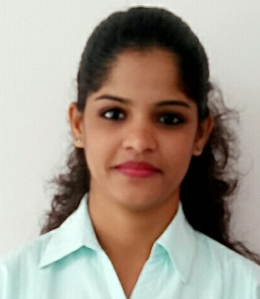

PERSONAL SUMMARY

Target-driven professional with a proven track record of circa 3 years which includes 2+ years as Senior Process Associate in Claim Settlement process; having in-depth knowledge of Compliance, Quality and various such metrics involved in claim process. At present exploring my expertise in Banking Domain (ATM Monitoring) and nourishing new skills simultaneously. Ambitious, enthusiastic and possessing excellent interpersonal skills with a well-earned reputation for easily establishing rapport, building key relationships, and eventually heading the performance list.

Effective in both self-managed and team environments. Energetic, excellent time management skills and results-driven for successfully managing a team and achieving corporate objectives.

CORE COMPETENCIES

Team ManagementStrategic Planning DynamicSkills
.
.
.

Leading, Mentoring and Monitoring | Vision & Forecasting Objective setting | High energy levels Highly motivated | Innovative and Decisive Influencing skills
Training sessions  In-House forums | Developing & Evaluating options | People Skills Eager to learn | Confident Helpful
Dynamic environment & development opportunities that fosters growth | Creating Action Plan Implementation Continued Improvement | Positive Attitude Meticulous Enthusiastic | Detail oriented Unbiased Self-Assured

WORK EXPERIENCE

AGS Transact Technologies Ltd
Jun'16

Till Date
Executive Monitoring - Banking Outsourcing
Processes Handled: State Bank of India & State Bank Group.

- Continuously monitor and manage the SLA against service delivery, so as the SLA is conformed to on a daily & monthly basis.
- Analysing the ALL MS Standing on daily basis to highlight deviations & service delivery shortcomings ATM wise. Action based on analysis including daily email communication highlighting the impact of the noted SLA failure & suggesting corrective measures to operations team and respective LHO officials.
- Preparing & validating monthly reports by capturing the MTD ATM wise SLA adherence. This report is shared with the internal management including Project Manager & Account Manager by 5th of every month. Once approved by PM & AM the same report is shared with the LHO officials (AGM & DGM).
- Also reponsible for addressing the issues raised by Bank officials through emails on real time basis. Ensuring the SLM calls are logged and closed with the OEMs within the ETA.

Accenture India Pvt. Ltd.
Aug'14 to Mar’16
Senior Process Associate – Order To Cash
Processes Handled: Acosta Sales & Marketing.

- Responsible for reviewing and validating the claims with accordance to the SOP and also by performing the basic research on the claim file and by communicating with client and the customers as per the need.
- Validated claims to be processed in accordance with deduction management guidelines. To intimate the customer about the claim settlement status.
- Reviewing the dashboards frequently for downloading the new claim requests.
- For unsettled claims informing the customers with detailed explanation keeping the Business Managers, Claims Specialist and Management Supervisor in loop.

COMPUTER PROFICIENCY

1) Operating System – Windows XP / 98 / 2000 / 2007
2)Applications – MS Office, Tally 9.0
3)Additional – Internet Surfing.

EDUCATION

- Bachelor of Commerce (63%) – Mysore University (2012)
- Higher Secondary School Certificate (73%) – Mysore State Board (2009)
- Secondary School Certificate (64%) – Mysore State Board (2007)

INTERESTS LANGUAGES

Cinema Comedy, Thriller, Mystery, Suspense English Proficient
Music Rock, Old Hindi Classics, EDM, Trance Hindi Proficient
Travelling Beaches, Road Trips, Bike Rides Kannada Basic

Date :

