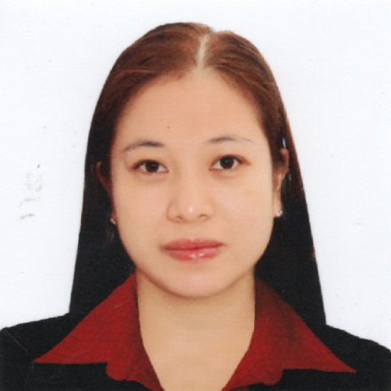
Diane
Diane.338801@2freemail.com

Basic Information

Age : 33 years old
Date of Birth : September 21, 1983
Place of Birth : Inosluban, Lipa City, Batangas
Sex : Female
Civil Status : Married
Nationality : Filipino
Height : 5’4 ft
Weight : 58 kg
Citizenship : Filipino

Personal Profile

I am a hard worker with a good communication skill who work effectively in a team and has the ability to meet deadlines. I am looking for a new challenge where I can use my existing skills and further develop my career.

Employment

Sales Representative
January 2010-January 2013
ERICCO Everything Retail Industrial and Commercial Company Inc.
ACE Hardware SM City Lipa, Batangas

Sales Coordinator
February 2013 –June 2013
ERICCO Everything Retail Industrial and Commercial Company Inc.
Handyman Do It Best Robinsons Place Lipa

Sales Representative
August 2013 – August 2014
Philips Electronics and Lightning Inc
Maquilling Builders Hardware Ayala Highway Lipa,Batangas

Overseas Filipino Worker (OFW)
Domestic Helper
August 2014 – December 2016
Jedah KSA, Saudi Arabia

Duties and Responsibilities

- Serving customers at the sales counter.
- Offering face to face advice to customers on the store products.
- Maximizing store revenue by suggesting upgrades insurance and add-ons to customers.
- Processing returns and refunds as required in line with company procedures.
- Occasionally being responsible for the stores security including being its key holder.
- Using the stock management system to log, check, locate and move stock both in and out of the store.
- Ensuring that all areas are clean and adhere to the company’s clear floor policy and health and safety requirements.
- Making sure that any item which removed from a display column is replaced immediately after a sale.
- Handling customer complaints in a calm manner
- Managing cash and payment system in accordance with company procedures and policies

Educational Background

Secondary Education
Bugtong na Pulo National High School
Bugtong na Pulo, Lipa City, Batangas
2001-2002

Primary Education
Inosluban – Marawoy Elementary School
Inosluban, Lipa City, Batangas
1997-1998

I hereby certify that the above information and given are true and correct to the best of my knowledge and belief.

