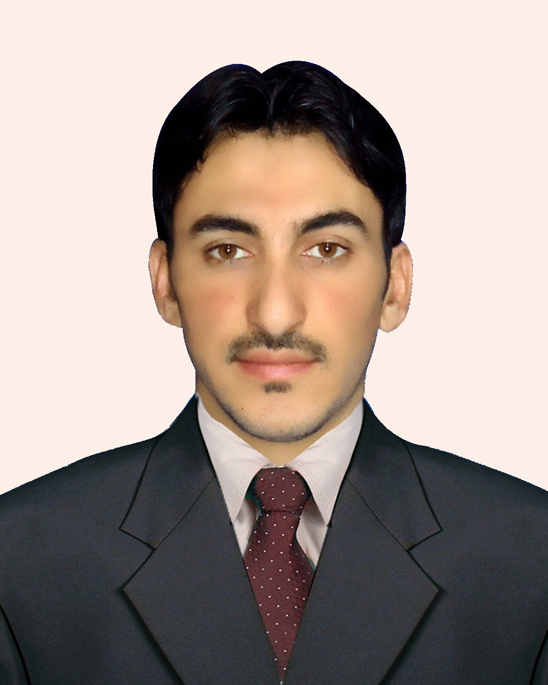
mURAD
mURAD.338817@2freemail.com
CAREER SUMMARY – Objective
Looking for an opportunity to join a leading organization. Searching for an opportunity to work for well-established company like yours where my skills and training will be put to good use.

area of interest: Financial accounting/ data entry/book keeping

Summary | I am degree holder of bachelor in business administration. (FINANCE).

Personal information
- Profile: Male ,age 24 ,Married
- Nationality: Pakistani
- Religion: Islam
- Language: English,Urdu, Pashtu
- Current Location: Village Naryab district Hangu Pakistan
Educational Credentials

Degree |  | Percentage
BBA(HON,s) Bachelor in business administration.  (IBMS) Agriculture university Peshawar. |  | 64.30% CGPA 2.72
FSC science |  | 65.36 %
SSC Science |  | 65.14 %
EXPERIENCE
- 1 year experience with AGRICULTURE EXTENTION sector as a accounting data entry clerk.
duties & responsibilities
- Responsible of all the daily transactions records like, sales invoices, purchase inventories, receipts and payments, accounts receivable, accounts payable of in accurate account filling system.
TRAINING/INTERNSHIP
3 months office internee in MCB BANK ltd.
Professional Courses / Certifications/Computer Skills
- Peachtree Accounting
- Quick book Accounting
- Tally ERP 9
- MS excel and ms word
personal SKILLS
- Open- minded & ability to quickly identify opportunities to reduce waste .
- verbal Communication ,Job Knowledge
- Excellent communication and relationship-building skills
- Ability to communicate effectively with at all levels of employees and managers.
- Highly energetic and self-motivated resource.

