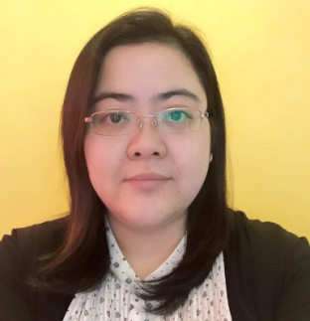
MARIA
MARIA.338837@2freemail.com

OBJECTIVE

To build a long - term career in Logistics, Shipping, Administration, Coordination, Customer Service and Operations that offers professional growth and continuous learning opportunities.

SPECIAL SKILLS

- Teamwork
- Initiative
- Problem Solving
- Flexibility
- Computer Skills (MS Office)
- Excellent Typing Speed: 50 WPM
- Detail oriented
- Core competencies
- Able to multi- task

WORK EXPERIENCE

CNS LOGISTICS LLC
JAFZA, Dubai, UAE
December 12, 2013 – January 8, 2017

Position: Logistics Coordinator

  - Plans & coordinates with the documentation, transportation and warehouse to manage the timely flow of customer’s orders.
  - Provide and maintain good customer service
  - Monitoring the loading/ offloading of customer’s cargo inside the warehouse to ensure the timing and checking the damages or shortages of the cargo to and from the warehouse
  - Encoding in the WMS system to facilitate the movement of products and materials to and from the warehouse
  - Documents and escalate any customer service issues and or shipping /receiving errors
  - Experience in E-Mirsal II (Import / Export / Transfer documentation)
  - Prepares Delivery Advice, Invoice & Packing List, HS Code and Transfer of Ownership
  - Keeping track of incoming shipments and export shipments in KPI system
  - Preparing customs submission (Normal submission, Exit/ Entry)

CAPIZ ELECTRIC COOPERATIVE, INC. (Electric Distribution Utility)
May 5, 2003 – September 18, 2013
Roxas City, Capiz, Philippines

Position: Customer Service/ Information Officer

- Receive complaints, queries & suggestion thru walk-in and phone calls
- Inform all radio stations or medias with the coops new policies, schedule of power interruption and activities
- Handles the processing of new, additional or transfer of electricity
- Assist superiors in information / membership drives
- Provides information assistance to other section, division and departments of the coop and provides technical research assistance to the general public on rural electrification program
- Conduct seminars on weekly basis to the new consumers regarding the cooperatives policy, obligation and their rights as a consumer
SEMINARS
- Consumer Welfare Seminar May 2005
- Classification & Categorization of Documents June 2009
- Formal Letter Writing Skills Training August 2011
EDUCATIONAL BACKGROUND

College: UNIVERSITY OF SAN AGUSTIN
BS Computer Engineering
1999-2002

