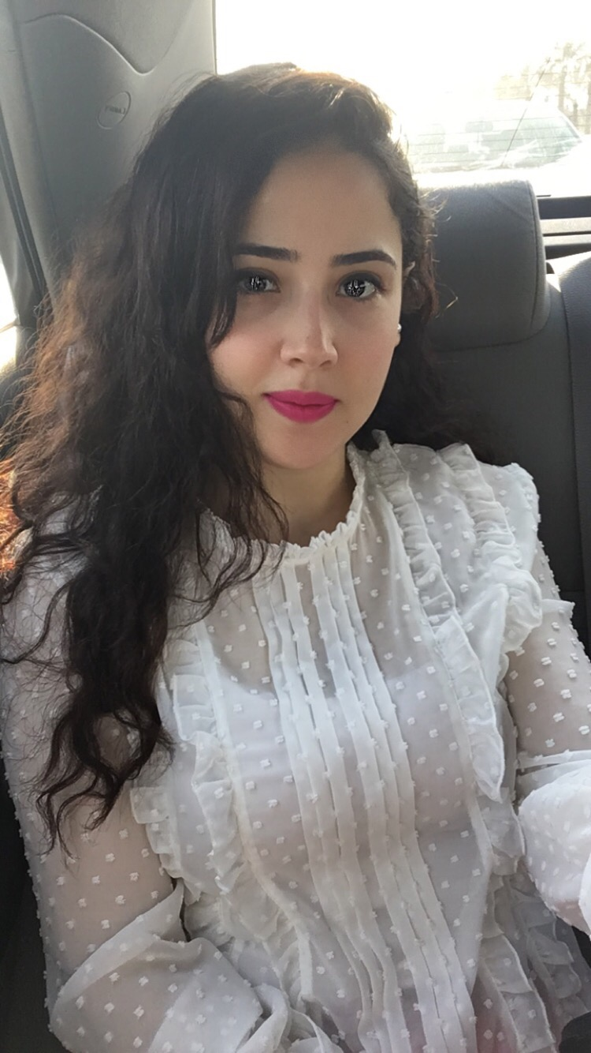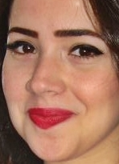
Hanan
Hanan.338939@2freemail.com

EDUCATION
2006/2011 Faculty of Pharmacy and Biotechnology, German University in Cairo, Egypt Bachelor Degree, Grade: B+
2004/2006 High School- Certificate, Cairo, Egypt Grade 91.0%

SKILLS SUMMARY
- Good interpersonal skills, working work with the clients and their colleagues.
- Confidence.
- Developed clinical pharmacy skills including monitoring patient therapy and drug information.
- Built dispensing skills and methodical administrative recording gained at El-Ezaby chain Pharmacy
- Demonstrated strong communication and decision making skills when providing informed advice on OTC lines to customers in a community pharmacy environment
- Established interpersonal and team work skills enabling me to operate effectively as a member of multi-disciplinary teams during working at Ahood AL Khaleej International Co.

PROFESSIONAL EXPERIENCE
Ahood AL Khaleej International, Kuwait September 2014/October 2016
Medical Representative

Heliabrine Products (WRINKE FILLER SERUM, SOLAR DEFENSE SUN CREAM, EYELASHES AND BROWS STRENGTHENER)

- Planning work schedules and weekly and monthly timetables.
- Identifying and establishing new business
- Attending and organising trade exhibitions, conferences and meetings
- Reviewing sales performance
- Organising conferences for doctors and other medical staff
- Keeping detailed records of all contacts

Envision Marketing& Advertising Agency, Cairo, Egypt January 2013/May 2014
Senior Medical Advisor
- Acting as a medical resource of the company, particularly of the clinical trial group.
- Representing the company during the international meetings.
- Providing strategic ideas to the medical, as well as, the marketing management.
- Developing the design, and also approve the promotional materials
- Working with team members from scratch on creating medical and pharmaceutical materials
- Sharing the creative department on other team members in creating the best idea to deliver client message
- Answering the questions related to the medical or technical protocols and products.
- Making the appropriate content for different awareness campaigns (online, outdoors, public activities…) in both English and Arabic
- Revision, editing and translation of all promotional materials
- Training and education to internal medico-marketing staff
- Answering medical or technical questions of other teams and act as a medical resource to the company as a whole to enable colleagues (designers, art directors, creative directors) to work efficiently and find specific marketing concepts

Pharmazone General Trading Company, Kuwait March 2012/December 2012
Medical Representative
Revitol Products (Keratin Hair Serum, INSTANT COLLAGEN EYE FIRMING SERUM, COLLAGEN AND CAVIAR SERUM, WHITENING AND MOISTUIZING LOTION, SKIN WHITENING Deodrant)

- Arranging appointments with doctors, pharmacists and hospital medical teams, which may include pre-arranged appointments or regular 'cold' calling
- Organising conferences for doctors and other medical staff
- Prepare Medical Presentation and Brochure for the new products
- Conduct Qualitative and Quantitative research on different market segments to prepare a strategic plan with time lined tactics for the company portfolio

El-Ezaby Chain of Pharmacies, Cairo, Egypt September 2011/February 2012
Staff Pharmacist
- Dealing with insurance based prescription.
- Knowing very well the covered medications by each insurance companies.
- Dealing with patients and handling prescriptions.

El- Hadeeka ElDawlya Pharmacy, Cairo, Egypt August 2010/December 2010
August 2009/December 2009
Intern - Staff Pharmacist
- I have practiced to recognize the classification of the drugs and their trade names and how to arrange them in the pharmacy
- Started to learn how to read the prescription and how to deal with the patients as well
- Another important thing was the procedure of ordering drugs from the medical companies.

CERTIFICATIONS
2014 Career certificate - Marketing Diploma in American University in Cairo, Egypt

Fundamentals of marketing certificate

PROJECTS
Drug Design
Graduation Project using Molecular Operating Environment (MOE) program with Grade: A+
Using a specific compound/drug, I created a pharmacophore model to virtually screen through a database of drugs and identify potential drug candidates.

PERSONAL DATA
DATE OF BIRTH:
- February1st, 1990.

PLACE OF BIRTH
- Cairo, Egypt

LANGUAGES
- Arabic: Native
- English: Fluent
- German: Fair

MARITAL STATUS
- Married

Soft Skills:
GUC Stuff
- Communication skills and Presentation skills
- Critical Thinking and Scientific Method
- Research Paper Writing (RPW)
- Academic Study Skills (AS)
- Academic English Course
- Academic German Course

Personal Characteristics:
- Good memory to memorize the upcoming medications
- Honest, dependable with Excellent Interpersonal skills
- Team oriented, organized and manage time well.
- Possess Leadership skills; Enthusiastic and Assertive.
- Self-motivated and ambitious
- Ability to work in a group or individually according to the job requirements
- Ready to work under pressure and time limits

REFERENCES:
Available upon request

