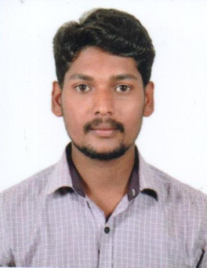
RESUME

S/o Joseph Shathraj
# karama, dubai
E-mail: emanuwal.338940@2freemail.com

CAREER OBJECTIVE:
To begin a career in the field of ELECTRICIAN & A/C Technician in an organization where I can develop by contributing to the realization of organization goals and thereby making the optimum utilization of my skills and expertise.
Education and Qualification

2011-2012 MORD TECH from Don Bosco Technical Institute, Hassan.
2009-2011 ITI from Don Bosco Technical Institute, Hassan.
2008-2009 SSLC from Government Secondary School, Hassan.
STRENGTHS
Easily Adaptable and ability to learn faster.
Good Interpersonal Skills and highly Confident.
Positive attitude and belief in team work & hard working.
WORK EXPERIENCE: (INDIA)
- Worked as an Electrician & A/C Technician in ANANT CARS AUTO PVT LTD (Mahindra & Mahindra Ltd and Renault). From 19-Sep-2011 to 19-April-2013.
- Worked as an Electrician & A/C Technician in Kalyani Motors (Maruthi Suzuki) From 10.07.2013 to 21.03.2016
- Trained in Suzuki MSPIN # 409587. basic, advance, SDT ,ciaz , shvs, s-cross, air-condition system, air fuel system and electrical )
- Auto Garage Multi brand worked for 1 year
TECHNICAL SKILLS:
- Basic computer knowledge.

PERSONAL SKILL SET:
- Ability to deal with people diplomatically.
- Comprehensive Problem solving abilities.
- Very much interested in studying new technologies and developing new techniques.
- A quick Learner and a self-starter with excellent communication, demonstrational and managerial skills.
- Have Keen interest in working with your reputed company.
EXTRA CURRICULAR ACTIVITIES
- Participation in all the cultural activities.
- Sports: Cricket, Volley Ball & Foot Ball.
- Driving
LANGUAGES KNOWN
- English
- Kannada
- Telugu
- Tamil
- Hindi
PERSONAL DETAILS:
Name : Emanuwal
Date of Birth : Jan 16th 1993
Gender : Male
Marital Status : Single
Nationality : Indian
Religion : Christian (RC)

DECLARATION
I hereby declare that the above mentioned Information is true to the best of my knowledge and belief.

Emanuwal

