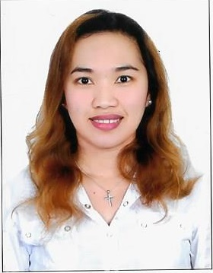
Merrarie

Email Address: Merrarie.339005@2freemail.com

CAREER OBJECTIVE:

To have a position in your company/organization that would make the most of my skills and work experiences, as well as bring out the best of my abilities and capabilities.

EMPLOYMENT HISTORY:

November 2013 – Present Al Qudrah AL Dahabiyah Technical Works L.L.C Dubai, UAE
Operation In Charge / Officer
- Responsible of the day-to-day operations of the company.
- Schedules the itineraries of the cleaners as well as client requests.
- Supervises company personnel from their daily workloads and payrolls.
- Task to meet up potential clients/customers for bookings and schedules.
- Managing customer issues.
- Visits Work site.

April 2013 - October Al Qudrah AL Dahabiyah Technical Works L.L.C Dubai, UAE
Supervisor / Schedule Coordinator
- Schedules the itineraries of the cleaners as well as client requests.
- Supervises staff/cleaners from their daily workloads and payrolls.
- Task to meet up potential clients/customers for bookings and schedules.
- Received calls for bookings.

June 2011 – Oct 2012 VISTA SEE SHOPPING CENTER
AD Curato St., Butuan City
Sales Supervisor
- Responsible for the operation of the store’s sales team.
- Initiates policies, marketing tool and promotional events for the store.
- Supervises promo personnel to achieve sales quota required.

PERSONAL INFORMATION
Home Address : Prosperidad, Agusan del Sur – Philippines
Gender : Female
Age : 28
Date of Birth : May 23, 1988
Civil Status : Single
Citizenship : Filipino

EDUCATIONAL BACKGROUND:

June 2004- March 2010 Saint Joseph Institute of Technology
Butuan City, Agusan del Norte
Bachelor of Science in Electronics and Communications Engineering

June 2000- March 2004 Prosperidad National High School
Prosperidad, Agusan del Sur

June 1994- March 2000 Philippine Normal University – Agusan Campus
Prosperidad, Agusan del Sur

SKILLS
- Experience in Marketing and Sales
- With Good English Communications Skill
- Computer Literate: MS Office Applications (Word, Excel, Powerpoint)

I believe that all of the experiences I have gained are best to the position I am applying for. I solemnly declare that above information is true to the best of my knowledge and beliefs.

