Personal Information
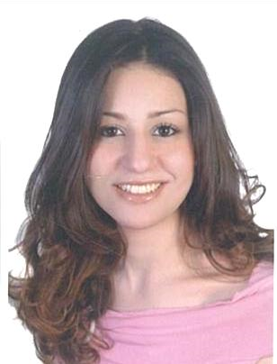
Name : Salma
Date of Birth : 30.09.1984
Nationality : Egyptian
Marital Status : Single

E-mail | : salma.339048@2freemail.com

Career Objectives

My long term objective is to develop my knowledge and skills in tourism as to become expert in my field and to expand my career experience worldwide.

Education

2001 - 2006 : Faculty of Archeology
BSc degree in Egyptology with merit
Cairo University, Cairo - Egypt

Work Experience

Feb 2015 - Present | All In Travel – DMCC  Operation Executive – Wholesale in Dubai, UAE
Oct 2014 - Jan 2015 | Mazaya Travel & Tourism - LLC  Tour Operator – Inbound & Outbound in Dubai, UAE
Oct 2013 - Jul 2014 | All In Travel – Egypt Branch  Senior Of Operation Department – Wholesale in Cairo, Egypt
Sep 2010 - Aug 2013 | Wings Tours & Nile Cruises  Senior Account Manager of Operating British & European  Markets – Inbound in Cairo, Egypt
Nov 2009 - Aug 2010 | Executive Travel
Tour Operator – Inbound in Cairo, Egypt
May 2009 - Oct 2009 | Flamingo Travel & Tours  Tour Operator – Outbound in Cairo, Egypt
Jan 2008 - Dec 2008 | Nile Travel International  Tour Operator – Inbound in Cairo, Egypt
May 2008 - Aug 2008 | Moon Valley for Tourism Investment  Sales Agent – Part Time – Cairo, Egypt
Jun 2007 - Dec 2007 | Golden Marriott Tours
Reservation Agent – Cairo, Egypt.

Languages

Arabic : Mother Tongue
English : Excellent in both written & spoken

Computer Skills

Very good user of the following programs:

- Microsoft Office.
- Internet, Intranet & E-mail.

Courses & Certificates

- Regular English, Intermediate Stage from the American University in Cairo. o General Italy, Basics.
- Microsoft Office of Mind Format Center.

Personal Skills

- Hard worker and work under pressure.
- Excellent communications skills.
- Quick Learner.
- Productive & Self-Motivated.

Hobbies

- Reading.
- Photography.
- Traveling.

