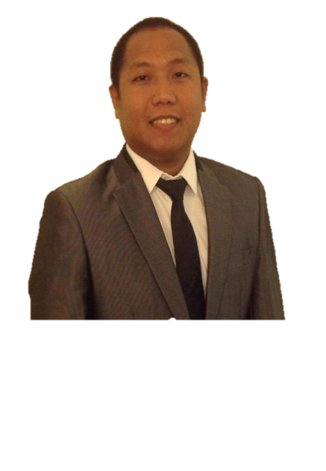
GODWIN
GODWIN.339097@2freemail.com

Personal Information

Nationality: Filipino
Religion: Roman Catholic

Objective

- Obtain a position in a company where I can help the company grow and develop my skills and move into roles of greater responsibility.
- Exceed expectation and provide a wonder full experience to all guests.
- Motivate and guide other colleague on their career path.

Educational Attainment

BACHELOR OF SCIENCE IN COMPUTER MANAGEMENT- Diploma

University of Perpetual Help Rizal-Las Piñas, Philippines
Year Graduated: 2007

Summary of Qualifications and Skills

- Proficient in Microsoft Word, Power Point and Excel.
- Exemplary problem-solving skills; able to identify problem and implement corrective processes.
- Strong communication, interpersonal and presentation skills.
- A skilled communicator; able to synthesized and deliver complex information to diverse audience.
- Strong leadership skills; able to prioritized, delegate tasks, and make sound decisions quickly while maintaining a focus on the objective.

Achievements and Recognition

- Atlantis Legend on the Month Nominee – April 2014 & August 2011
- Letter of Recognition from the President and Management Director of Atlantis Hotel – June 2013
- 1997 – 2002 NCAA Medalist Athlete (Swimming and Track & Field)

Training and Seminars Attended

Competence in the inspection of personal protective Equipment (PPE) for work at heights
European Rope Course Association  (Qualified Rope Course Instructor) | - ID No. (January 2016-2019)
Life Guard Safety Skill Training for Special Facilities - Elis & Associates ILTP Course Completion (Special Facilities | - Cert No.  18th February 2016 – 18th February 2017  Note: Updated training January 22,2017
Advance First Aid, CPR, AED for Adults & Infants - ECSI (Emergency Care & Safety Institute) | - Wadi Adventure, Al Ain  18th February 2016 – 18th February 2017  Note: Updated training January 22,2017
Pediatric and First Aid and CPR Training ECSI (Emergency Care & Safety Institute) | - Atlantis the Palm, Dubai  15th June 2015
Basic Food Handling | - Atlantis the Palm, Dubai  26th June 2015
PADI Open Water Diver

WORK EXPERIENCE
Assistant Activity Manager
Wadi Adventure, Al Ain
November 2016 to Present
- In-charge in the daily Park Operations (Surf pool, Rope Course, White Water Rafting, Kayaking, Wake Boarding)
- Conducts Performance Evaluation
- Lifeguard Supervisor
- Revise SOP’s that fits on the daily operation.
- Certifying Safety Equipment for Rope course and Rescue Equipment.
- Create and Revise Risk Assessments for existing and new activity.
- Facilitates First Aid training (Lifeguards, Rope course Instructors, Rafting guides, Kayaking Instructors, Wake boarding Instructors and Surf Instructors)
- Schedule Trainings
- Staff Schedule
- Create new Revenue Activity Programs
- Events Organizer & Host (Wadi Adventure Race (WAR), World Rafting Champion Ship 2016, International Slalom Kayaking)

Team Leader
Guest Recreation
Atlantis the Palm, Dubai
July 2012 to November 2015
- Create new revenue generated programs
- Create Programs for Daily Activity for Hotel Guest and Corporate Team Building Events
- Hosting Daily Activity for Hotel Guest
- Supervising Daily operation (Recreation, Tennis Court, Water Sports, Water Park Cabana)
- Logistics
- Event planner
Activity Coordinator
Club Rush / Kids Club
Atlantis the Palm Dubai
United Arab Emirates
August 2010 to July 2012
- Receptionist
- Attend to the guest inquiries.
- Organized birthday parties and other events.
- Host Daily Activity for Kids and Teenagers
- Assisting guest on the wall climbing activity
- Assisted the daily themed or activities for kids and teen agers.
- Hotel Mascot

Aquaventure Life Guard
Atlantis the Palm, Dubai
United Arab Emirates
July 2009- August 2010
- Maintain continuous surveillance of people in swimming pools and artificial rivers
- Provide safety information to people
- Spot hazards or potential hazards and take measures to prevent accidents
- Perform rescues in the event of drowning or swimming accidents
- Perform first aid and CPR according to the demands of adverse situations
- Ensure that all pool equipment is stored safely and that any lost items are kept in a safe place
- Waterpark Ride operator
- Testing all the park rides before the opening.

Banquet Waiter
The Manila Peninsula (November 2008)
Heritage Hotel (January – March 2008)
Manila, Philippines
  - Set banquet rooms and halls as per instructions of the event manager
  - Prepare rooms in terms of adjusting lights and setting appropriate temperature
  - Ensure that all decorations have been set in accordance to the instructions
  - Make sure that tables are set with linen, dishware and flatware
  - Fill glasses with water before guests arrive and refill them during the course of the event
  - Greet guests in a cordial manner as they arrive
  - Offer welcome drinks and ask guests if they need any additional items
  - Set banquet table with dishes
  - Carry food trays to the tables
  - Ensure that food is replenished in a quick manner
  - Deliver beverages as per guests’ instructions
  - Anticipate guests’ needs continually and fulfill them appropriately
  - Clear dishes and flatware once the event has ended
  - Clean premises along with stripping table cloths and napkins
Assistant Swimming Coach and Swimming Instructor
Xavier School San Juan & San Beda Alabang
Philippines
2006-2007
- Computing GPA Reports for grade 6-7 students.
- School Swimming Coach
- Swimming Instructor for Elementary Student

Lifeguard & Pool Maintenance
Santarosa Estate
Philippines
2004-2006

Extra Curriculum
- Event Coordinator (Kids Birthday Party)
- Swimming Instructor for Special Kids

