Raja
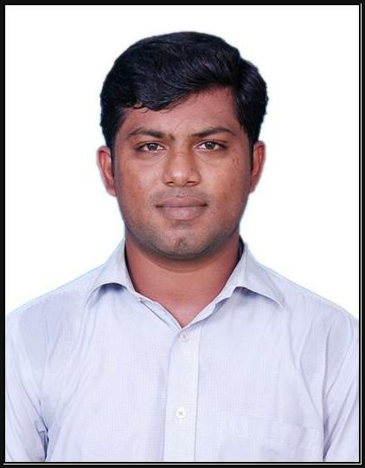
Software & Web Design and Developer / Application Programmer

Email | raja.339104@2freemail.com

OBJECTIVE

I intend to establish myself as Software Developer / Web Developer / Application Programmer /Analyst with an integrated business solution provider through a long time commitment, contributing to the company's growth and in turn ensuring personal growth with in the organization.
I believe that my technical, functional and communication skills will enable me in facing the challenging career ahead.

Education

2013 - 2015 | M.E - Computer Science and Engineering - 7.1 CGPA
 | PSN College of Engineering and Technology, Anna University
 | Chennai, Tamilnadu, India
2007 - 2011 | B.E - Computer Science And Engineering - 64%
 | National College Of Engineering, Anna University
 | Chennai, Tamilnadu, India

Experience SUMMARY

Having 3.6 Years of Experience in Programming and Software & Web development Comprehensive experience in Web Applications, Windows Applications and Database. Expertise in C#.NET, ASP.NET MVC, WordPress
Good knowledge and experience in SQL Server 2000 and 2008, HTML, CSS, AJAX and Java Script, J-Query. Excellent team player with good communication skills
PROFESSIONAL EXPERIENCE-I

Aug 2015 - Dec 2016 Software Consultant

BRASSY TECHNOLOGIES PVT LTD, CHENNAI, INDIA

Involved in analysis, design and development of Web based Applications.
Have good comprehensive problem solving abilities, ability to deal with people diplomatically, and willingness to learn.
Worked extensively with Data Adapter, Data set, and Data Reader as a part of ADO.net to access and Update database.
Involved in development of Web applications using WordPress, Asp.Net, MVC and involved in performance tuning of the application.
Involved in Production Support & Maintenance, interacted with the clients and support them.
EXPERIENCE-II

OCT 2013 - JAN 2015 System & Network Administrator (PART TIME)

NTL Call Taxi, Tirunelveli - Tamilnadu, INDIA

Worked on router/hub/switch configuration, network implementation and

troubleshooting.

Experienced in working with technical teams and equally comfortable working alone without supervision and providing computer peripherals, cabling switching, and LAN solutions etc.
Maintain the proper communication through LAN between various departments. Investigating, diagnosing and resolve all network problems.
EXPERIENCE-III

Jun 2011 - Jun 2013 Junior Software Developer

Object90 IT Solutions Pvt Ltd, Tirunelveli, Tamilnadu, India

Good working knowledge on Application development and maintenance life cycle process.
Extensive Experience in SQL server Database design-SQL queries, stored procedures, Cursors, view and triggers using SQL server 2008.
Expert in debugging an application using the debugging tools provided by the Visual Studio.NET Excellent troubleshooting techniques.
Experienced in programming and Testing of Web applications. Effective in working independently and collaboratively in teams.
Work History

Sep 2016 - Dec 2016 Online Application for Tourism Company

Sunshine Travel - Al Ain, Abu Dhabi, UAE

Technologies: WordPress, HTML, CSS, JQuery, BootStrap, MySQL, WAMP Server, Hosting Support

Sunshine Travels is located in Al-Ain, U.A.E. It is one of the leading company in the sector of Tours and Travels.
They need website look and feel as an international standardized so that we move to WordPress technologies to create a website with online air tickets, hotels booking, cruise, car, passport and visa service in online with mail conversion system, we uses the following control to increase the look and feel that photo slider with accordion control, Youtube and Vimeo supported plugin and location embedding with google maps and etc.
JUN 2015 - Sep 2016 Online Food Ordering Application

HotTouch Restaurant - Chennai, India

Technologies: .Net Framework 4.0, C#.Net, ASP.NET MVC, AJAX, MS SQL Server 2008. IIS Server

Online Food Ordering System is developed in Asp.Net MVC for providing an online solution for reaching a maximum number of customers. Online business is growing fast with most of the business are providing online services for customers.This website contains diﬀerent types of forms with diﬀerent types of food varieties available to the user to buy though online. As normal e-commerce, site user should register with the application and get username and password to buy products. Users can select diﬀerent options available on the site to add the product to cart. After adding products to cart users can move to payment process by selection available payment options and pay the amount. Confirmation is received from mail and SMS with order id. List of forms and reports are Cart detailed report, payment report, customer report, my account, change password, Fast food, south Indian food, north Indian food, ice cream ordering..etc.
Feb 2016 - May 2016 Hospital Management and Online Appointment Booking Service

COC Hospitals - Chennai, India

Technologies: WordPress, HTML, CSS, JQuery, BootStrap, MySQL, WAMP Server, Hosting Support

Chennai Orthopaedic Center(COC) Hospitals is located in Chennai, they already had their website but they need to change its look and feel as international standardized so that we move to WordPress technologies to create a website with online appointment fixing, individual doctor availability with its time and location, individual doctor online mail conversion system, photo slider with accordion control, Youtube and Vimeo supported plugin and also location embedding with google maps.
Aug 2015 - JAN 2016 PBX Call Manager Software

City Sky Maid Service－ Dubai, UAE

Technologies: .Net Framework 4.0, C#.Net, MS SQL Server 2008.

City Sky Maid Service LLC provides cleaning service and leading one in Dubai. This project provides a call manager solution to the City sky maid users to track and manage the call.This project is developed to capture all the call details and their customer details and call pop to the end users to eﬀectively manage the calls A PBX (private branch exchange) is a telephone system within an enterprise that switches calls between enterprise users on local lines while allowing all users to share a certain number of external phone lines. It also manages customer and account profile, service request and call histories. MDS algorithm is applied for database security
JUN 2011 - JUN 2013 Educational Centre projects

Colleges in Tirunelveli - Tamilnadu, INDIA

Technologies: .Net Framework 4.0, C# .Net, ASP.NET, AJAX, MS SQL Server 2008R2, NS2, MATLAB

Final year college students from various stream were approach here for their projects in diﬀerent platforms based on IEEE, IEEE Transaction or Non-IEEE papers.
We explained everything which is presented in the paper and its algorithms and guide them to create software in particular platform
We developed software, documentation, presentation slides based on students requirement within the dead line with modifications.

Technical Summary

Programming Tools - C# .NET, Asp.Net – MVC, HTML, CSS, JavaScript, Jquery, Ajax, Bootstrap, CCNA Databases - MS SQL Server 2014, 2012, 2008, 2005, Entity Framework, MySQL, MS-Access. Development Tools - VisualStudio.NET 2005/2010/2010/2015, Wordpress, Dreamviewer. Operating System - Windows 2003, 2008, Server, Windows XP, 7/8/10, Linux (Ubuntu, Fedora), MAC Servers - IIS, XAMPP, WAMP, LAMP, MAMP
Tools - Microsoft office 2003/2007/2011, Photoshop
Personal Information

Nationality : Indian
Date of Birth: 18/02/1990
Gender: Male
Visa Status : Visit Visa
Languages Known : Tamil, English, Malayalam

