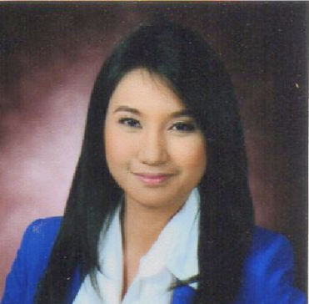
CHARDELINE
CHARDELINE.339110@2freemail.com

OBJECTIVES:
To be able to work in a career-oriented and pursue a demanding role that promotes personal growth and uplift professional development. To work for a reputable organization having congenial working environment and where challenging opportunities are available to contribute towards the development of organization.

EDUCATIONAL BACKGROUND:
Tertiary: 2011-2015 San Beda College Alabang
Bachelor of Science in Business Administration
Major in Human Resource Development Management
Alabang, Muntinlupa City, Philippines

Elementary & Secondary: 1999-2011 St. Michael’s Institute
Bacoor, Cavite, Philippines

WORK EXPERIENCE:
July 20, 2015 – January 20, 2017 Expert Global Solutions ROHQ Asia Ltd. (An Alorica Company)
HR-Benefits Associate

Essential Duties & Responsibilities

- Performs initial processing of benefits review of documents to ensure completeness of all the required forms and documents prior to forwarding to the government agencies
- Able to respond to basic benefits questions or inquiries from the employees
- Ensure that all pre-employment requirements of employees are complete and valid
- Supports government mandated employee benefits – filing, claims, etc.
- Assist employees by answering questions about the company’s benefits packages, how these packages affect the employees’ dependents and how to fill out benefits application
- Monitoring of inquiries regarding HMO-related concerns
- Perform other duties as assigned by management

November. 10, 2014- February 20, 2015 American Data Exchange Corporation (ADEC Innovation)
Internship (400 hours)
Compensation & Benefits Department/ Employee Relations Department

Essential Duties & Responsibilities

- Validation of documents
- Encoding of leave, overtime and undertime of employees in the system
- Assist in HR events like christmas party, valentines party etc.
- Perform other duties as assigned by management

SKILLS AND ABILITIES:
- Good Communication Skills – Use proper English grammar and have a good speaking voice.
- Technical skills –Is computer literate (MS Office – Excel, PowerPoint, Word, Outlook etc.) and knows how to operate different machineries needed in the workplace.
- Leadership Skills – Has robust leadership skills and flexible. Willing to try new things and able to adapt to difficult situations.
- Personal skills – Is able to work under pressure, trustworthy, self-motivated, honest and reliable, fast learner, confident, professional (can work individually or in group), has initiative, and loyal.
- Analytical Skills – Has keen attention to detail. I am interested in improving efficiency on assigned tasks.

AFFILIATIONS:
2013 – 2014 Varsity Player, Badminton of San Beda College Alabang
2012 – 2013 Secretary, Junior People Management Association of the Philippines of San Beda College Alabang
2011 – 2015 Member, Junior People Management Association of the Philippines of San Beda College Alabang
2011 – 2012 Member, Bedan Volunteer of San Beda College Alabang
2009 – 2011 Varsity Player, Volleyball of Saint Michael’s Institute

AWARD:
March 2015 Dean’s Lister

PROFESSIONAL DEVELOPMENT:

July 2016 WITHHOLDING TAX ON WAGES & EMPLOYEE BENEFITS
Seminar, Microtel-UP Technohub Diliman, Quezon City, Philippines

October 2014 SAP Business One Certificate
San Beda College Alabang
Alabang, Muntinlupa City, Philippines

September 2013 ORGANIZER - THE CHALLENGES OF HUMAN RESOURCE MANAGEMENT
IN THE 21ST CENTURTY/ THE RELEVANCE OF HUMAN RESOURCE
IN THE WORKPLACE
San Beda College Alabang, Muntinlupa City, Philippines

September 2012 ORGANIZER - HUMAN RESOURCE PRACTICES IN THE OUTSOURCING INDUSTRY
San Beda College Alabang Muntinlupa City, Philippines

