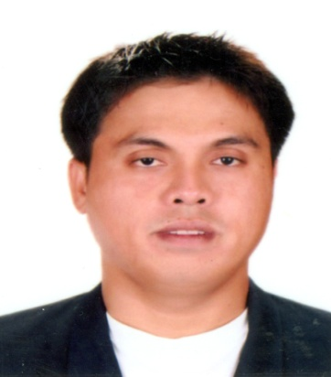
Christopher
Christopher.339116@2freemail.com

C U R R I C U L U M V I T A E
CAREER OBJECTIVE: A highly motivated with positive and confident outlook, enjoy overcoming obstacles which require discipline and enthusiasm to contribute and to make a difference in everything. To acquire a dynamic and flexible job opportunity that will provide proper exposure that could further enhance my skills and capabilities as part of the growth of the company.
Position Applied for: Waiter

WORK EXPERIENCE:

Waiter
Diego Café
Nation Tower, Corniche Road
October 5, 2016 up to present

- Preparing the dining table, and serving the food and the drinks to the costumer.
- Taking orders, serving food and drinks and giving the guest satisfaction.
- Taking drink orders, offering appetizers.
- Delivering drinks correctly and quickly. Keeping drinks refilled.
- Keeping unneeded items removed from the table.
- Offering dessert and coffee.
- Responsible in collecting payment or costumer’s bill.
- Keeping the restaurant clean while working.
- Helping other staff and responsible in resetting the shop/ restaurant for the next shift.
- Also assigned in the kitchen to help other task needed assigned by my supervisor.

Waiter
Hacienda Inn Restaurant
Candelaria Quezon, Philippines
July 2013- December 2015

- Collect payments from customers.
- Write orders on slips, memorize orders, and enter orders into computer for transmittal to kitchen staff.
- Take orders from customer for food and beverages.
- Serve food and beverages to the customer well prepared and serve specialty dishes at tables ass required.
- Prepare bills and the total meal cost to the customers.
- Inform customers of daily specials.
- Clean tables and counters after the customers have finished.

Hilton Hotel Abu Dhabi
Bellboy
May 2012-January 2013

- Helping guests out of vehicles and unload their luggage.
- Assisting the guest into the hotel and on to their rooms
- Helping guests to find their rooms.
- Teaching our guests to operate door locks and room lights and assisting with roll-away beds or cribs.
- Helping our guests with laundry pick-up and any delivery.
- Responsible in keeping the entrance and lobby areas tidy and welcoming.

Waiter
La Barida Restaurant
Candelaria, Quezon
January 2010- January 2012

- Manage the daily operation in the restaurant.
- Greeting the guest or costumers in a good manner.
- Preparing the dining table, and serving the food and the drinks to the costumer.
- Responsible in taking orders, serving food and drinks and giving the guest satisfaction.
- Taking drink orders, offering appetizers.
- Delivering drinks correctly and quickly. Keeping drinks refilled.
- Keeping unneeded items removed from the table.
- Offering dessert and coffee.
- Responsible in collecting payment or costumer’s bill.
- Responsible in resetting the restaurant for the next shift.

EDUCATIONAL BACKGROUND

TERTIARY: Two years System Administration and Software Programming

Manuel S. Enverga University
April 3, 2008 Candelaria, Quezon Philippines

SECONDARY : Manuel S. Enverga University
Malabanban Norte Candelaria, Quezon
March 2005

PRIMARY: Pahinga Norte Elementary School
Candelaria, Quezon Philippines

PERSONAL INFORMATION

Birth Date : December 6, 1983
Birth Place : Candelaria, Quezon Philippines
Age : 33 years old
Sex : Male
Civil Status : Single
Height : 5'7”
Weight : 80 kg

The information mentioned above is certified true and correct.

---------------------------
Applicant Signature

