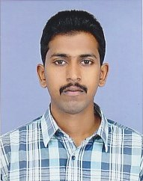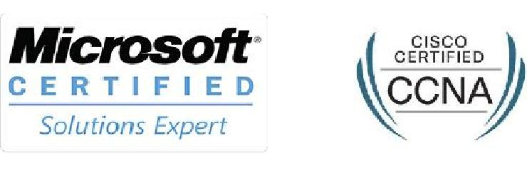

JYOTHEESH
JYOTHEESH.339118@2freemail.com
CURRICULAM VITAE

Career Objective

To get a competitive and challenging job to deliver best of my skills and make best use of my efforts in gaining experience and reward and to have reputed position in the IT field.

Summary of Qualifications & experience

3 Years of Experience in Network/System Administration. CCNA Routing & Switching

MCSE 2012 SERVER

Diploma in Electronics and Telecommunication

Executive Profile

- Customer-focused IT professional with over 3 years of valuable experience
- Well Knowledge in designing and implementation of Wireless networks.
- Major strength includes expertise in LAN with implementing the optimal network and security infrastructure.
- Designed and implemented VLANs, Inter-VLAN Routing in campus network.
- Hands-on Expertise in configuration of cisco routers and switches.
- Improved client relations based on technical efficiency and problem-solving skills.
- Experience in installation and Configuration of Windows Active Directory , DNS server and file server.
- Knowledge of VMware and Hyper V.

Work Experience

- Network Administrator Aug 2014 – Jan 2017
Aeterna Solutions Pvt.Ltd,Thrissur
- System Support Engineer Nov 2013- July 2014
Motilal Oswal, Thrissur

Technical Certifications

- Cisco Certified Network Associate in Routing & Switching
- Microsoft Certified Solutions Expert in 2012 Server
- CCTV Security Specialist

Academic Qualification

- Diploma in Electronics and Telecommunication, Institute of Engineering, Kerala
- Plus-Two, from Board of Higher Secondary Educations, Kerala.

- S.S.L.C from Board of Public Exams, Kerala

Personal Profile

Date of Birth : 01st Aug 1991

Nationality : Indian

Gender : Male

Marital Status : Single

Languages Known : English, Hindi, Tamil & Malayalam

Visa Status : Visit Visa

Strengths

- Ability to work under pressure

- Hardworking and flexible

Declaration

I hereby declare that the above information and fact are true to the best of my knowledge and belief.

