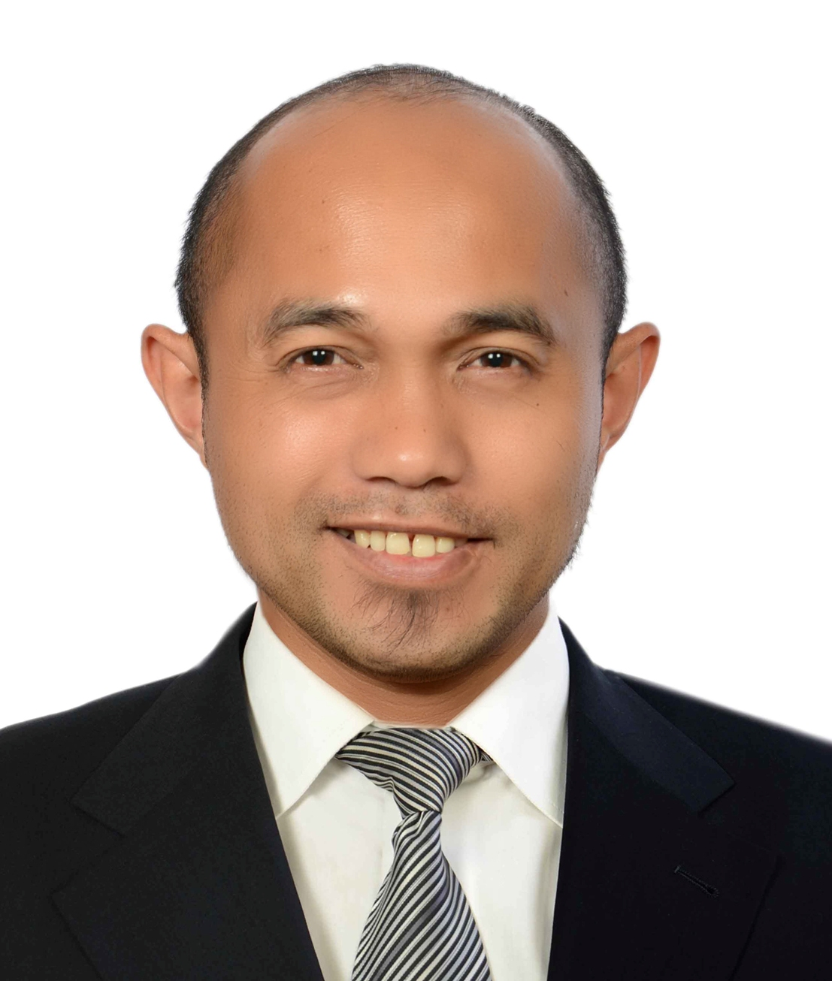
R A N D Y
RANDY.339143@2freemail.com

CURRICULUM VITAE (CV)

SUMMARY OF QUALIFICATIONS:

Highly adaptable skill in a diverse and fast working environment, with extensive experience in office, finance and HR administration, Facilities management, procurement , contract administration, document control, education and training, account management, support of operations, events organizing, material handling and logistics.

• Detailed administrative, accounting and procurement procedural processes that reduce redundancy, improve accuracy and efficiency, in the achievement of organizational objectives.
• Focused and results-oriented in supporting complex, deadline-driven operations; able to identify goals and priorities and resolve issues in initial stages.
- Management of contracts, documents and maintenance proposals in the support and overall coordination, procurement, material handling and implementation of the contracts.
- Emphasis on the Safety, Health and Environment workmanship in the project site.
• Comprehensive support for executive-level staff including scheduling of meetings, coordinating travel and visa arrangements, logistics , drafting of business correspondence , effectively managing all essential secretarial and administrative tasks, and recording and documentation of meeting and training proceedings.
• Proven ability to interact in a culture of different nationalities, and can easily adapt to any situation, identify needs of both clients and the company, thus, ensuring good client- company relations.
- Human Resources administration, management and coordination
• Emphasis on accountability and transparency on financial related tasks based on SOPs.
- Facility Management Services and building maintenance ensuring minimal breakdown and routine inspection for preventive maintenance.
- Event management with detailed attention to details from planning, set-up, maximizing of resources, implementation and after event arrangements.
• Manages the Database System – Enterprise Resource Planning (ORACLE-ERP) from PO Creation to delivery and closing.
• Document filing, organizing, controlling and management.
• Well versed in Microsoft Office Applications such as EXCEL, WORD and POWERPOINT and Microsoft Outlook.

A. ACADEMIC QUALIFICATIONS:

BACHELOR’S DEGREE: Bachelor of Science in Commerce, Major in Marketing,
POST GRADUATE STUDIES: 15 Units of Masters in Business Administration
ADDITIONAL CREDENTIAL: *Passed the Philippine Government Licensure Exam for Teachers (LET)

B. WORK EXPERIENCE

WORK EXPERIENCE 1: FACILITIES ADMINISTRATOR CUM PROCUREMENT and DOCUMENT CONTROLLER
COMPANY: MULTIPLEX SERVICES

One of the Global Leaders in the Construction and Facilities Services Industry
Period of Employment: February 28 to the Present
Project Site: Al Bahr Towers (Abu Dhabi Investment Council), Abu Dhabi, United Arab Emirates

Duties and Responsibilities:
Directly reporting to the Senior Facilities Manager, Serving as the backbone of all admin, HR and Procurement related services and functions in supporting 35 Manpower MEP Maintenance team and 9 Management Staff assigned in Al Bahr Towers (Abu Dhabi Investment Council), Abu Dhabi specifically:
- Process the Access Cards and Material Gate Pass of the MEP Team. Coordinate the same with the General Services Department for its approval.
- Assists, Maintains and facilitates Manpower Team database in the processing and renewal of employee records such as Passport, EID cards, CVS, qualifications and Visas
- Supports in carrying out duties for Office Management, Document Control, Finance and Administration.
- Maintain and update Commercial Trade Licenses of all Maintenance Specialists and Contractors for the project site
- Submit and Manage Monthly Financial Statement and Accruals against cost codes of the project operations.
- Accounting and managing of Petty Cash and reimbursement claims.
- Coordinates Invoice payments and claims for and against the client.
- Purchase required materials for MEP Maintenance as per approved list of suppliers and against raised work orders by the client.
- Releasing of Purchase Orders to the suppliers as integrated in the DOS system of the company.
- Categorize Purchase Orders in the PO Registry as per Mandatory Cost Codes: Variation or Extended Works, Ad-hoc, Establishment Costs, Contract Services.
- Materials Management and Maintenance as per project needs and requirements.
- Manage Contracts of specialists and contractors as per content and scope of work .
- Organized the supplier lists for Mechanical, Electrical and Plumbing.
- Manages the CHEOPS system in facilitating Purchase Orders (local or foreign) from its Creation, Approval, Release, Delivery, Payment, Invoicing and closing.
- Drafts proposals for Routine Maintenance Works and Variations or Extended Works.
- Submit Invoice to Client as per agreed contracts and works related to variations or extended works.
- Maintain the Office Supplies of the Site Project Office.
- Works hand in hand with the storekeeper in maintaining stock for the Material Requests and with the Facilities Coordinator for Authority to Work Permits and for work orders related to materials for its closing.
- In-charge of the timesheet of the Staff and MEP Team, submitting the Summary Attendance Sheet to Head Office for payroll based on provided payroll cut-off dates.
- Mobilize the MEP Maintenance Team in close coordination and communication of all work orders raised that needs immediate action and purchase of materials as per samples and specific details of the needed material for repair, installation, servicing, maintenance, stock, replacement, replenishment.
- Batching of supplier invoice for materials delivered by suppliers and services rendered by specialists forwarding it to Accounts Department for Payment.
- Take and record minutes of Weekly Client-Project Meetings, Staff Meetings, Helpdesk and Customer Service Meetings, and Monthly Operational Meetings
- Facilitate the processing of the admin requirements of the Facilities Services Team such as: Staff uniforms and PPE, recording of OT in the Timesheet, Visa processing requirements, transport services, document control and filing, office sundries, HSE induction, scheduling of Meetings, MEP Tools and Equipment.
- Delegate tasks assigned to the Facilities Coordinator and Storekeeper.

WORK EXPERIENCE 2: ACCOUNT ADMINISTRATOR
COMPANY: MANNAI CORPORATION QSC

The company is the exclusive dealer of GMC, Subaro, Cadillac and leader in providing Oil Products and Services back to back with Facility Management Services in the Oil and Gas Industry in Qatar
Period of Employment: July 2011 up to December 31, 2015
Project Site: Operations Head Office, Doha, Qatar

Career Highlights and Responsibilities:
- Managed the Agency/Service Agreements, Tenders between Global Accounts- Principal and our company being the exclusive agent in the delivery of Oil Products and Services to our clients in the Oil and Gas Industry.
- Integrated Cold calling sales and telesales services related to Direct Sales.
- Formulated and systematized the procedures in the Fabrication requests in procuring and buying materials needed to reduce redundancy to meet needs utmost priority and immediate action.
- Negotiated and submitted sales offers on a regular basis as per required bid closing dates of Request for Quotations.
- Organized the supplier lists for Fabrication and Direct Sales in the spreadsheet as per structural materials, lifting equipments, services and third party certifications and consumables, codes, job cards and material grades and specifications.
- Manages the ORACLE ERP system in facilitating Purchase Orders (local or foreign) from its Creation, Approval, Release, Delivery, Payment, Invoicing and closing.
- Purchased materials as per required specifications and detailed requirements.
- Coordinated the shipping, delivery and needed materials of to our Oil and Gas Clients and updated regularly the inventory list of the materials and that needs to be replenished , fabricated and manufactured.
- Designed the contents of the Comparative Purchase Evaluation Analysis, Purchase Indent/Authorization Details and CAPEX forms and Purchase Orders in considering details for Freight Costs, DDP Charges, Taxes and Custom Clearances.
- Work hand in hand with Logistics Department in the implementation of a strict compliance by the supplier on the lead time, provision of Test Certificates and punctuality in the delivery arrangements.
- Established contacts and maintained approved good suppliers for basis of repeat orders .
- Resolved clarifications, conflicts and issues at the initial stages of the offer before closing sales deal.
- Bad performing suppliers where cut off in the list of approved suppliers.
- Accounting and Auditing of invoice payments, reimbursement of petty cash requests, closing of advance payments and booking of purchase orders.
- Execute sales reports against offers under categories of Won, Lost, Regret on a Monthly, Quarterly, Yearly Basis.
- Ageing of Orders that needs to be closed due to unresolved issues .

WORK EXPERIENCE 3: CONFERENCE CENTER CUM BUILDING SERVICES COORDINATOR
COMPANY: MANNAI CORPORATION QSC
JOINT VENTURE: TRANSFIELD MANNAI FACILITIES MANAGEMENT SERVICES (TMFMS)
Period of Employment: September 2008 – June 2011
Project Site: ExxonMobil, Al Wosail Tower, Doha, Qatar

Career Highlights and Responsibilities:

• Reporting to the Facilities Manager.
• Focal Point Person and Front Office Coordinator in managing customer service operations of the conference center at the Al Wosail Tower (Exxon Mobil Doha, Qatar Operations Office) from reservation, planning, preparations, implementation and evaluation. Coordinated scheduling of senior management meetings, departmental activities and training, and other business related functions at the conference center which include 7 main conference rooms and 10 meeting rooms.
- Supported the catering team in the events requiring food and beverages and highlighted food and safety management.
- Event organizing and maximized available resources in terms of AV equipment availability, space and floor plan management, furniture set-up, manuals, food catering system, safety requirements, digital presentations required in the specific event.
• Managed and maintained the SCALA audio visual display signage of the Building according to the client's preference of displayed announcements such as Training, Special Events and Programs, Safety Announcement, Meeting Schedule, TV programs and current projects ,success stories, and major accomplishments.
- Formulated the general guidelines in the reservation of the Conference Center.
- Documented and provided the details in the OIMS (Office Integrated Management System) as reflected in the Facilities Working Documents.
- Lease and tenancy agreements are regularly monitored subject for processing, renewal or termination.
- Proposals were submitted in the improvement of the delivery of services and identified needs of the building services and the conference center requiring immediate action.
- Recognized and awarded by the client on a quarterly basis the achieved NO Loss Time Injury and Zero Accidents in our area of responsibility.
- Planned and organized the day to day activities of the AV Technician with regards to the preventive maintenance of the AV Equipment.
- Team Leader for the Soft Services staff: Mailroom, Housekeeping, Transport, Helpdesk and Conference Center
- Supervision of the housekeeping attendant assigned and maintain cleanliness and hygiene in the conference center.
- SNAG and PUNCH Lists for building services maintenance (e.g. Carpentry, MEP, HVAC) were immediately resolved and acted upon.
- Minimal breakdown of AV equipment due to strict implementation of regular routine inspection.

