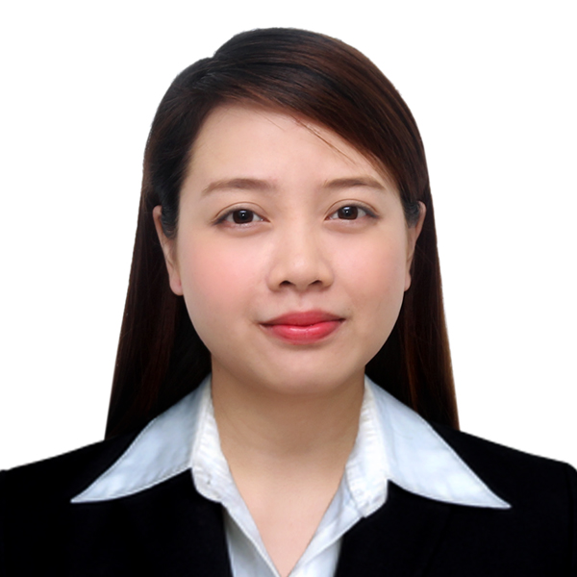

Marie
Marie.339167@2freemail.com
CAREER OBJECTIVE

To improve and expand my knowledge and skills and to establish an employment in a friendly environment. Interested in finding employment with a company which will utilize my skills.

WORKING EXPERIENCE

Company: Versant BPO Solutions
1705F One San Miguel Building, One San Miguel Avenue, Pasig City
June 2013 – December 2016
Position: Administrative Staff

Duties: Provide general administrative and clerical support including mailing, scanning, faxing and copying to management.
Maintain electronic and hard copy filing system.
Perform data entry and scan documents.
Assist in resolving any administrative problems
Run company’s errands to post office and office supply store
Answer calls from customers regarding their inquiries.

Company: IBM Daksh Business Process Services Phils. Inc
UP- Ayala Techno-Hub
Bldg. G Commonwealth Quezon City
October 2011 – March 2013
Position: Customer Service Representative

Duties: Handling customer concerns.
Effectively understand and resolves customer's issues.
Enter new clients information.
Transfer customer to the right department.

Company: 168 Commercial ( Exclusive Distributor of Seleta)
Lagundi, Mexico Pampanga
January 2010 – October 2011
Position: Office Staff

Duties: Perform data-entry, documentation, printing and filling duties.
Support the officers in daily admin roles and to keep stock of stationary supplies for the department.
Create and maintain useful databases for the department.
Perform some research duties as and when required by the team
Assist the Dept head to maintain a proper attendance and tracking report for the Dept.

SKILLS
Computer Literate
Can work under pressure
Attentive to details
Customer service skills
Organizational Skills

EDUCATIONAL ATTAINMENT
Tertiary Business Office Information Service
ACLC College
Baliuag, Bulacan 2008-2010
Secondary San Rafael National Trade school
San Rafael, Bulacan 2004-2008
Primary San Rafael Elementary Central School
San Rafael, Bulacan 1999-2004

PERSONAL DATA

Date of Birth : September 03, 1991
Place of Birth : Negros Occidental
Civil Status : Single
Age : 25
Sex : Female
Height : 5’00”
Weight: 41kgs
Nationality: Filipino
Religion: Catholic

I hereby certify that the above information is true and correct to the best of my knowledge and belief.

