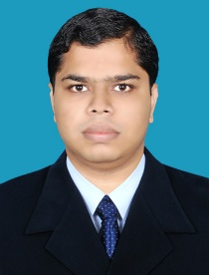
SHAHIDH
E mail: SHAHIDH.339171@2freemail.com

OBJECTIVE

Intended to build a career with organizations environment with committed and dedicated people and to work in an organization that provides ample scope for learning and growth, which would help in developing overall personality, serving and assisting customers, also learn and guide others towards a more amicable and fruitful organization as a whole.
QUALIFICATIONS

Course | Institute | Board/University | Year of Passing | Percentage
Plus Two | SNMHSS Kerala | Government of Kerala | 2004 | 55.00%
SSLC | PPTMYHSS Kerala | Government of Kerala | 2002 | 40.00%
Pursuing Bachelor of Arts | Co Operative collage Kerala | Calicut University | Pursuing | Pursuing
TECHNICALQUALIFICATIONS

- IATA / UFTAA Foundation and EBT (Montreal at Canada)
- Airport Management and handling.
- Airline Ticketing & Travel Management.
- C.R.S {Saber, Amadeus and Galileo }.

Issue on : 27/10/2009
Passport Expiry : 26/10/2019
WORK EXPERIENCE

- Worked as a Travel Coordinator with King Tours and Travels for 4 Months
- Worked as a Travel Coordinator with Al Hind Tours and Travels for 3 years
- Completed 1 month Internship at Calicut International Airport under Airport Authority of India (Calicut)

PERSONAL DETAILS

Date of birth : 06-08-1985

Sex : Male

Marital Status : Single

Visa status : Visit Visa(Till 8th April 2017 )

Nationality : Indian

Languages Known: English, Malayalam, Hindi & Arabic

DECLARATION

I hereby declare that all the above information given by me is true to the best of my knowledge and belief.

