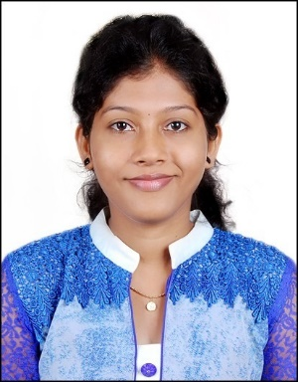
Niveditha
Niveditha.339173@2freemail.com
M.Sc, B.Sc Computer Science

CURRICULUM VITAE
Objective
To obtain a responsible and career oriented position in a challenging environment where I can enhance my knowledge and utilize my potential effectively and diligently for the gain of the company and grow with them.
Educational Qualification
- M.Sc in Computer Science from Mangalore University,Konaje,Mangalore.
- B.Sc in Computer Science from Govinda Dasa College , Surathkal, Mangalore
- P.U.C(PCMB) form Govinda Dasa College , Surathkal, Mangalore
- 10th form M.R.P.L School, Bala, Mangalore
WORK EXPERIENCE
Institution name | Position | Period | Year
Government First Grade College for Women, Mangalore | Guest Lecturer | 2 Years | 2014-2016
Little Flower Composite P.U. College, Kinnigoli | Part Time Lecturer | 3 Years | 2012-2015
Madeleine P.U. Colllege, Mulky | Part Time Lecturer | 2 Years | 2012-2014
Proficiency
- Languages : C, C++
- DBMS Packages : Oracle
- Front End : VB 6.0
- Operating Systems : Windows XP, Windows 7
- Web Designing : JAVA, HTML

Academic Details
 | Education | Year of Passing | Percentage | Grade of passing
10th |  | 2005 | 65.4% | 1st class
P.U.C |  | 2005 – 2007 | 57% | 2nd class
B.Sc |  | 2007 – 2010 | 66.38% | 1st class
M.Sc  1st sem |  | 2010 | 70.6% | Distinction
2nd sem |  | 2011 | 72.33% | Distinction
3rd sem |  | 2011 | 67% | First class
4th sem |  | 2012 | 85% | Distinction

Personal Skills:
Comprehensive problem solving abilities, excellent verbal and written communication skills, ability to deal with people diplomatically and hard worker.
Personal Details:

Sex : Female
Marital Status : Married
Nationality : Indian
Languages : English, Hindi, Kannada, Tulu
Visa Status : Husband Visa

Declaration:
I hereby declare that the above mentioned particulars are true to the best of my knowledge and belief.

