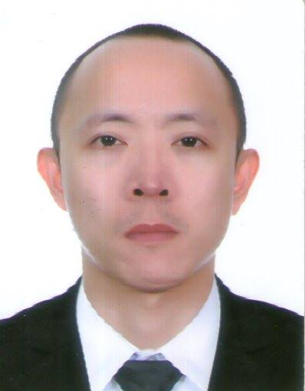

Frederick

Frederick.339224@2freemail.com

CAREER OVERVIEW

To pursue a highly rewarding career, seeking for a job in challenging and healthy work environment where i can utilize my skills and knowledge efficiently for organizational growth.

CAREER HISTORY

Graphic Artist March 2014 – Nov. 2016
Sid’s Party Needs - Las Piñas, Philippines

- Prepares work to be accomplished by gathering information and materials.
- Incorporate changes recommended by the clients into the final design
- Creating layouts for invitation cards and tarpaulins for family gatherings and occasions.

Business Process Associate Oct. 2012 – Jan. 2014

Amdatex Corporation- Las Piñas, Philippines
- Process and capture information to system according to methods and procedure
- Investigate on the property that was about to collateralize and their personal Encumbrances in order to approve their proposed loan to a bank.
- Typing of valid documents as required by the project.

Office Assistant July 2010 – Sept. 2011
E.V Suyosa Builders- Las Piñas City, Philippines

- Perform clerical duties including filing and inventory.
- Manage calendars and arrange appointments.
- Operate office machinery such as copier and fax machine.

Operations Manager Jan. 2008 – Dec. 2008
IMEX (International Mailing Exchange)- Quezon City, Philippines

- Operates international shipment services.
- Ensure liaison with agents and coordinated arrangement of shipments.
- Take responsibility for the shipment from its origin country until the shipment is delivered to warehouse.
- Review and sign off shipping documents while ensuring completeness and accuracy.
- Issue delivery order by sea and air.

Warehouse Assistant July 2006 – Oct. 2007
CHINSU Phils.- Cavite, Philippines

- Prepare and complete orders for delivery according to schedule (washing machine, motorbike, etc.)
- Receive and process warehouse stock products (pick, unload, label, store)
- Perform inventory controls and keep quality standards high for audits.
- Complete diary logs into inventory.

TRAINING

Cavite Computer Center Sept. 2014 - March 2015

Cavite, Philippines
- Photo Editing and Graphic Design
- Basic Computer Repair & Networking
- Advance Computer Application
- Basic Computer Application

Pierre and Paul Solutions Call Center Training March 2012
- Customer Service Representative/Technical Support

Southern Institute of Maritime Studies Feb. 2010

Cavite, Philippines
- Basic Safety Training

Food and Beverage Century Park Hotel Sept. 2009

Manila, Philippines
- Food and Beverage Services Seminar

QUALIFICATION

2005 Bachelor of Science in Information Technology AMA Computer University

PERSONAL DOSSIER

Date of Birth: November 21, 1981
Marital Status: Single
Nationality: Filipino
Height: 5'7
Languages Spoken: English, Tagalog

KEY SKILLS

- Friendly Personality and able to engage customers.
- Self-motivated, initiative, maintains a high level of energy Accuracy and Attention to details.
- Proficient in Microsoft office suite, Troubleshooting, Networking.
- Team-oriented employee focusing on the company goals.
- Driving License (Philippines)

