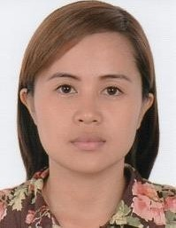

Experience
Diana
Diana.339242@2freemail.com
Secretary/Accounts Assistant (5 years) Jison, Hinolan & Co. CPAs

Feb 2012 - Jan 2017
(5 years)

Secretary/Accounts Executive
Jison, Hinolan & Co. CPAs | Western Visayas, Philippines
Industry Accounting / Audit / Tax Services

- Answering phone calls
- Meeting with the clients
- Organizing and maintaining paper and electronic files
- Data Encoding
- Compile data and prepare a variety of reports
- Reconciles records with internal company employees and management
- Handling mail and basic bookkeeping
- Writing communication letters and emails
- Update and maintain accounting journals, ledgers

Feb 2011 - Dec 2011
(10 months)

Customer Service Representative (CSR)
Panasiatic Solutions Call Center Inc | Western Visayas, Philippines
Industry Call Center / IT-Enabled Services / BPO

- Interacts with customers to provide and process information in response to inquiries, concerns and requests
- Responds promptly to customer inquiries
- Obtains and evaluates all relevant information to handle product and service inquiries
- Handles and resolves customer complaints in a timely manner
- Keeps records of customer interactions and transactions, details of inquiries, comments and complaints and details of actions taken

Feb 2007 - Oct 2010
(3 years 9 months)

Accounting Clerk
DEPARTMENT OF PUBLIC WORKS AND HIGHWAYS | Western Visayas,
Philippines
Industry Construction / Building / Engineering
- Update and maintain accounting journals, ledgers
- Data Encoding
- Writing communication letters and emails
- Filing, typing, copying and scanning

Education

2003-2007 ABE International College of Business and Accountancy
Bachelor's/College Degree in Commerce | Philippines

Major Accounting

About Me

Gender Female
Age 30 years
Nationality Filipino

