RESUME
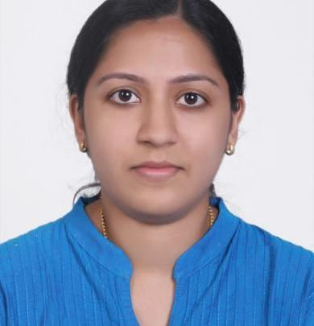

NEETHU ​(DHA ELIGIBILITY LETTER HOLDER)
Mob.no : C/o 971501685421

Email : neethu.339352@2freemail.com

CAREER OBJECTIVE

Seeking a challenging employment related to Pharmacy in an organization where

excellence, honesty and integrity are foundation for success. To work in an

organization which gives an opportunity to continuously develop and improve

management skills and where one’s skills are maximum utilized and appreciated.

PERSONAL PROFILE
Name in full | : | Neethu
Date of birth | : | 26.01.1989
Sex | : | Female
Marital Status | : | Married
Nationality | : | Indian
Religion | : | Christian
Languages known | : | English, Malayalam,Hindi
Hobbies | : | Making new friends,hearing music
Professional Registration No. | : | 43107 [Kerala State Pharmacy Council]
Visa Status | : | Residence

​PROFESSIONAL EXPERIENCE

- 2 years of experience as a Pharmacist from ST.Thomas Medicals Chemists and Druggists, Nellimukal, Adoor, Pathanamthitta [15.01.2014-29.02.2016]

- 2 months of experience as a Pharmacist trainee from Padmavathy Medical Foundation, Sasthamcotta, Kollam [12.07.2011-17.09.2011]

ACADEMIC QUALIFICATION

- M Pharm(2011-2013) : Dept. Of Pharmaceutical Sciences, Puthuppally

​M G University, kottayam

First Rank with Distinction 76% Marks

- B Pharm(2006-2011) : University College Of Pharmacy, Cheruvandoor

MG University , Kottayam 75% Marks

- Plus Two(2004-2006) : N M H S S, Kaithakuzhy

Board of Higher Secondary Examination , Kerala 83.5% Marks

●

SSLC(2004)

: M M H S S, East Kallada

Board of Public Examination, Kerala

82% Marks

RESPONSIBILITIES

- Checking and billing of the prescriptions by entering the details of the patient and medicinal information.

- Organize quick and accurate dispensing of medicines .

- Counsel and answer the patient’s questions regarding dosage, route of administration and special directions etc.

- Prepares purchase order , checks supply of medicines and enters the details including supplier name, invoice no., date ,medicine name, packing, quantity,expiry date ,rate, tax, mrp etc.

- Maintains appropriate storage of each medicines.

- Managing proper records and details regarding narcotic and psychotropic drugs.

ACADEMIC PROJECT

M Pharm : Formulation and Evaluation of hollow microspheres of Acyclovir In vivo evaluation in rabbit.

B Pharm : Survey of Immunomodulatory and abortifacient activity of some selected plants.

ACHIEVEMENTS

Industrial visit : MICROLABS, Bangalore

Seminars : 63 rd Indian Pharmaceutical Congress, Bangalore

- National Conference On Challenges In Drug Delivery Research, Amrita School Of Pharmacy,kochi
- National Scientific Seminar On Anatomy,Medical college,kottayam

- Epigenesis of Cancer and Biotechnology In Pharmacy,Department of Pharmaceutical sciences,Cheruvandoor,Kottayam

DECLARATION

I hereby declare that the details furnished above are true to the best of my knowledge.If you give an opportunity in your esteemed organization I will do my duties to the best of my abilities and your utmost satisfaction.

Place: SHARJAH
​NEETHU

Date : 31-01-2017

