Name: Nadeem
E-mail: nadeem.339410@2freemail.com

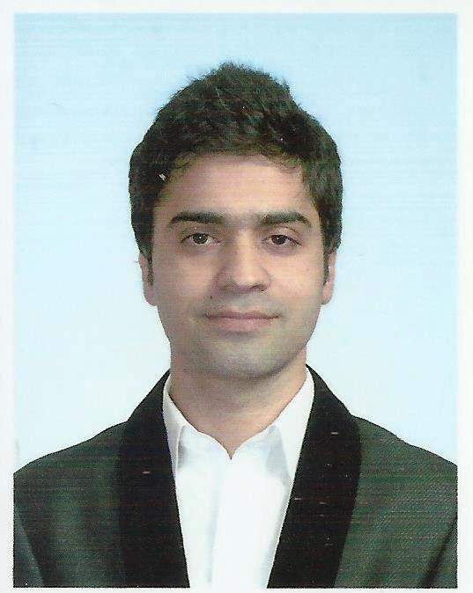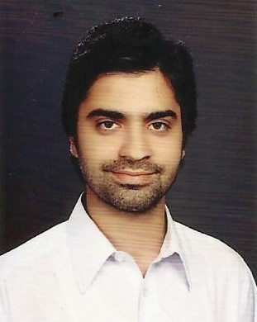

Personal statement (Objective)

I am a passionate, dedicated, bright, and service-oriented Pharmacist professional, with over more than 3 years of experience with a demonstrated history of working in the hospital and health care industry. I am currently holding an active RPh (Registered Pharmacist) License in KPK (Pakistan). Skilled in PHARMACY PRACTICE (Retail and Clinical Pharmacy), outpatient and inpatient pharmacy services, Clinical Research, Oncology Medicine, non-sterile compounding. Strong healthcare services professional with a Bachelor's Degree focused in Pharmacy from Comsats University Abbottabad and specialised Master degree in Clinical Pharmacy (M.clinPharm) from Cyberjaya University of Medical Sciences Malaysia. I wish to work hard for the success and betterment of the particular institute or an organization.

I would now like to utilise the skills and experience gained in the field of pharmacy and undertake a new challenge.

Education

- Pharm-D (Doctor of Pharmacy)
COMSATS Institute of Information Technology, Abbottabad Pakistan.
GRADE/C.GPA: 3.3

- Maters in Clinical Pharmacy (M.clinPharm)
Cyberjaya University of Medical Sciences, Malaysia
GRADE/C.GPA: 3.2

Employment History (Professional Experience)

1). Clinical Pharmacist
People`s Primary Healthcare Initiative (PPHI), KPK Pakistan
(September 2013 – September 2015) (2 years)

Achievements and responsibilities:

- Directly coordinated with physicians, other health professionals, and patients to ensure that the medications prescribed for patients contribute to the best possible health outcomes.
- Routinely provided medication therapy evaluations and recommendations to patients and other health care professionals.
- Served as a primary source of scientifically valid information and advice regarding the safe, appropriate, and cost-effective use of medications.
- Advised physicians on matters pertaining to drug usage and control within assigned hospital locations; participated in the development and delivery of continuing education programs for Pharmacy, Patient Care Services, Medical Staff and students and monitoring antibiotic usage.
- Participated in drug selection and maximizing therapeutic outcomes for patients.
- Provided information to patients about medications and their usage.
- Provided suggestions on therapeutic therapies including interactions.
- Therapeutic Drug Monitoring and participated in optimization of therapy.
- Did research work associated with Clinical Pharmacy and manage projects as a clinical pharmacist.

2). Retail Pharmacist
Al-Saeed Pharmacy & Chemist, KPK Pakistan
(October 2015 – August 2016) (10 months)

Achievements and responsibilities:

- Prepare prescriptions for patients.
- Provide suggestions on therapeutic therapies including interactions.
- Assists pharmacist technicians in filling prescriptions, counselling patients, and contacting other healthcare institutions when required.
- Maintains and stocks pharmacy products and checks their expiry dates.
- Records patients' drug therapies in computers and monitors negative drug interactions.

3). Clinical Pharmacist (Internal medicine and Surgery)
RHC Hospital, KPK Pakistan
(September 2016 – March 2017) (7 months)

Achievements and responsibilities:

- Conduct and evaluate medication histories, assess compliance and suggest modifications so as to achieve desired outcomes.
- Instruct patients in the proper use of prescribed drugs participate in patient care rounds with multidisciplinary teams to evaluate patient progress.
- Assist in training new employees
- Prepare compound and dispense drug and other pharmaceutical
Supplies.
- Review written prescriptions for dose, drug interactions and assures that drug is prescribing and dispense in proper manner.
- Verifies prescription accuracy and validity.
- Orally explains direction from using the drugs to patient.
- Therapeutic Drug Monitoring and participated in optimization of therapy.
- Did research work associated with Clinical Pharmacy and manage projects as a clinical pharmacist.
4). Trainee Pharmacist
GLITZ Pharma
(June – August 2012)

Achievements and responsibilities:

- Performed duties and tasks as trainee pharmacist in Production, Quality Assurance and Quality control department.

Current Professional Membership

- Pakistan Pharmaceutical council KPK, Pakistan

Conference and Training

- Had attended a workshop at Shifa international hospital, Islamabad about Patient Care for 2 weeks.
- Had attended a seminar of 2 days, at Shifa international hospital, Islamabad about The Role of Pharmacist and Patient Care.
- Had also participated in the workshop of one week, on Clinical Pharmacy Education and Services, held at COMSATS Abbottabad.
- International Seminar on Dengue in Islamabad Pakistan.
- Patient Care and Role of Clinical Pharmacist seminar at PIPS, Abbottabad.

Research and Publications

- Prescribing Pattern and Use of Antibiotics in Outpatient Clinics in Abbottabad Pakistan
Date: 2013
For the partial fulfilment of doctor of pharmacy

- "What I want for Pakistani Pharmacy Graduates, recommendations from personal experience" Archives of Pharmacy Practice 2015

- ASSESSMENT OF RISK FACTORS AND PROPHYLAXIS FOR VENOUS THROMBOEMBOLISM IN CRITICALLY ILL PATIENTS AT HOSPITAL PUTRAJAYA MALAYSIA
For the partial fulfilment of Masters in Clinical Pharmacy

Specialised areas training during Masters in Clinical Pharmacy

Attended ward rounds on daily basis, clerked cases, presented case reports, monitored lab reports, checked evidence based medications according to guidelines and solved drug and pharmaceutical care issues.

- Internal Medicine training at Kajang Hospital Malaysia
- Infectious Disease training at Serdang Hospital Malaysia
- Intensive Care training at Hospital Kuala Lumpur Malaysia
- Paediatrics at Hospital Seremban Malaysia
- Therapeutic Drug Monitoring (TDM) at hospital Seremban Malaysia
- Clinical Research at hospital Putrajaya Malaysia
- Geriatric Pharmacotherapy at Hospital Kuala Lumpur
- Total Parenteral Nutrition (TPN) at hospital Putrajaya Malaysia
- Evidence Based Medicine and Antibiotic Stewardship HKL Malaysia
- Psychiatry at Hospital HUKM Malaysia
- Medication Therapy Management

Community Services:

Pharmacist, Medication Therapy Adherence Clinic (MTAC) Warfarin, PPHI Basic Health Unit, Nowshehra KPK, Pakistan.
Pharmacist, Medication Therapy Adherence Clinic (MTAC) Diabetes, PPHI Basic Health Unit, Nowshehra KPK, Pakistan. (August 2013 – September 2015).

SKILLS:

Language Proficiency
- English: High Proficiency (speaking, reading, listening and writing)
- Urdu and Hindi: High proficiency
- Hindko, Punjabi and Pashto: High Proficiency
- Malay : Intermediate (speaking, reading and writing)
- Charismatic and confident public speaker
- Attended, organized and presented conferences, seminars, workshops and case reports for the purpose of Pharmacist education programmes.

Computer skills
- Mastery of Microsoft Office programs (Word, Excel, PowerPoint)
- Worked on multiple online data base systems (for example: fisician, ZriMed, Uptodate etc).
- Searching and comparing recent management guidelines, evidence based medicine and evaluating clinical literature.

