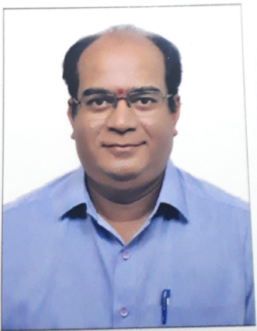

ASHOK
E-Mail: ashok.339439@2freemail.com
Objectives :

Looking forward to an opportunity to work in a Challenging environment, where I can utilize my knowledge skills in contributing effectively to the success of the organization and also for the improvement of my personal skills…

Academic Credential :

- The Institute Of Chartered Accountants of India- Intermediate Examination- Group I – In1999 November

- Completed Graduation – Bachelors Degree In Business Management ,Mysore University in the year 1991 with 60 %.

Work Experience

Present Working Experience : -( January 2008 to Present Date )

Accounts Manager in Veekay Agencies, Mysore-is Authorised Stockist for Servo Lubricants from India Oil Corporation Ltd.,

- Accounts book keeping

- Prepare financial Statement and supporting schedules according to monthly, quarterly, annually.

- VAT Accounting, Experience on VAT Returns.

  - Payroll Processing & Passing necessary closing journal entries.

- Responsible for making timely and accurate data entry of all invoices.

- Handling of Accounting & billing software in Tally ERP 9. And other SAP software.

- Co-ordination for Maintaining Stock Register.

- Prepare Bank Reconciliation Statement.

- Co-ordinate with the respective sales Managers or customers if any quarries.

- Preparing Daily and Monthly sales wise reports.

Previous Working Experience

Audit Assistant in M/s. Hariharan & Co., Chartered Accountants From October 1991 to December 2007

Training

- Completed 3 Years Article ship from October 1991 to October 1994 with M/s Hariharan & Co., Chartered Accountants, Mysore

Software familiar with :

- Knowledge of Operating System like Window 8.1

- Well versed with internet & e-mail.

- Application of software packages (word/excel/PowerPoint)

- Well versed in Tally ERP9 software.

Key Skills:

- Hard work accompanied with sincerity, punctuality and ability to manage stress.

- Willing to accept any type of related work.

- Capable of managing the task.

- Good in communication and presentation.

Personal Details:

 | Date of Birth | : | 27th July 1969
 | Nationality | : | Indian
 | Gender | : | Male
 | Language Known | : | Marathi, Kannada, English, Hindi,
 | Marital Status | : | Married

