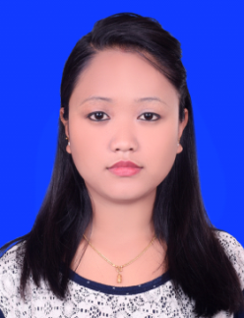
Namita
C/o-Mobile: +971501685421
E-mail: namita.339515@2freemail.com

Career objectives
To contribute high level of performance and competency in the fast growing company using my experience and expertise to enhance its assets and capacity internationally.

Personal skill & Competencies
- Positive attitude and strong responsibility with hard working.
- Good in English both written and oral communication.
- Eager to learn and open for further development/ Dynamic and easily adaptable
- Having warm ,friendly and engaging personalities
- Well versed in Microsoft Office (Word, Excel & Power point)

Work Experience
- 8 Month job training at lumbinizonal Hospital. Butwal
- 3 years job at Devdaha medical college & research institute. rupandehi
Job overview
- Checking, witnessing and administering controlled as well as scheduled drugs to a wide variety of patients.
- Assisting in the control of communicable diseases through preventive immunization programs.
- Reporting to the senior nurse, incidents of accidents, complaints or defects drugs, supplies or equipment.
- Following up patients after their discharge so as to make sure that they do not feel that they have been forgotten.
- Providing excellent patient care in a nurturing and supportive environment to a wide of patients.

3. 1.6 Month Bhat-Bhateni Supermarket & Department store, Maharajgunj, KTM, NEPALAs a Sale advisor
Job overview
- Greet customers with energy and enthusiasm in a timely, professional
- Maintain eye-catching effective display of merchandise.
- Build lasting relationships with customers by contacting them to follow up on purchases, suggest new merchandise and invite them to upcoming events..
- Maintain excellent store standards with regards to service, store layouts at atmosphere.
- Provide suggestive feedback to the department managers based from the customer request, queries and suggestions to help and increase sales profit.
- Guide and show the sales staff correct displays, branding and departmental layouts.

Education
- School Living certificate (S.L.C)(Green Plant Rupandehi )
- +2 Humanities ( oxford college butwal )
- A.N.M ( Lumbini Institute of Technical Sciences (C.T.E.V.T ) Butwal )

Personal Details
Date of Birth : 14TH Dec 1991
Sex : Female
Marital status : Married
Nationality : Nepal

Language spoken:-
- English, Nepali and hindi

DECLARATION
I hereby declare that the above given particular and details are true to the best of my knowledge and belief and I am also willing to give my best for the responsibility.

