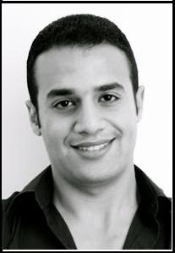Mostafa

mostafa.339547@2freemail.com C/o- +971501685421

Curriculum Vitae

Personal details

Date of birth: 12th of December 1986

Nationality: Egyptian

Work experiences

03/2015 – present Middle East Company for Chemicals LTD., Cairo, Egypt

→ Medical Tender Account Executive

11/2014 – 02/2015 League of Medical Defense, Sharm Al Sheikh, Egypt

→ Senior Physician

06/2012 – 08/2014 24/7 Medical Services, Hurghada, Egypt

→ Senior Physician

Internship

03/2011 – 03/2012 El Demerdash Hospital, Ain Shams University, Cairo

Education

09/2004 – 12/2010 Faculty of medicine, Ain Shams University, Cairo, Egypt

→ Degree: bachelor of medicine and surgery. M.B., B.ch (Good)

09/2001 – 07/2004 Mubarak (now El Horeya) Secondary Schools, Cairo, Egypt → High School Degree (excellent)

Part time jobs

03/2011 – 05/2012 Call Centre Worx, Cairo, Egypt

→ Sales Coach.

09/2008 – 09/2010 Ameco Tech Corporation, Cairo, Egypt

→Telemarketer agent.

Languages and IT skills

Languages: | Arabic: | Mother tongue
 | English: | business fluent
 | German: | basic knowledge
IT skills: | good knowledge in MS Office

Interests

- Sports

- Chess

- Reading

Mosatafa

