SHADI , MB, BS, FICO, ARBO, JBO
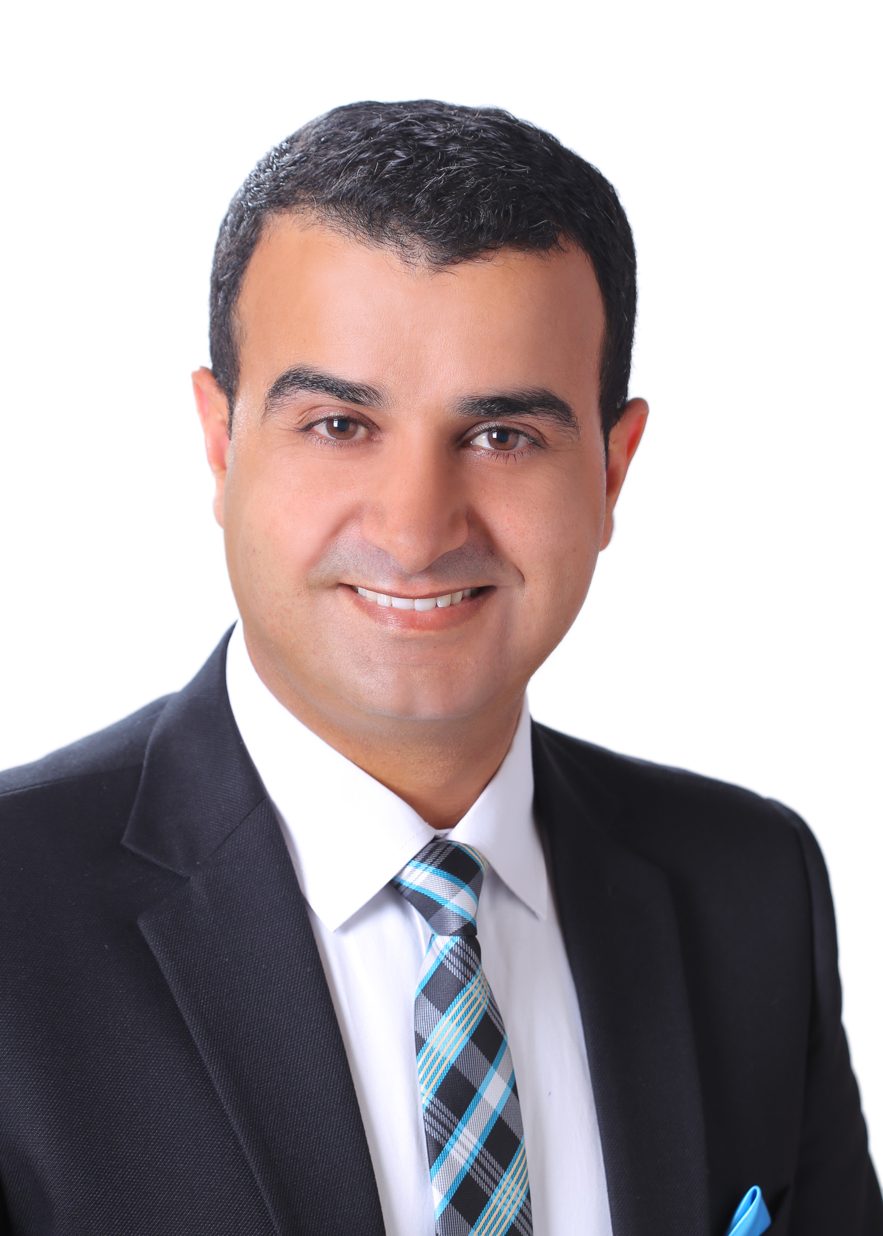

OPHTHALMOLOGY SPECIALIST

- HAAD Licensed
- DHCA Licensed
- SCFHS-KSA Licensed
- MOH-UAE Licensed

Abu Dhabi-UAE
E-mail: shadi.339562@2freemail.com

QUALIFICATIONS:

- Arab Board in Ophthalmology
- Jordan Board in Ophthalmology
- Fellow of the International Council of Ophthalmology (FICO)

LICENSES:

- Permanent license to practice the profession of Medicine issued in Amman in 11/6/2009 with Jordan Medical Association registration number: 16211/20001
- Permanent license to practice the profession of Specialist in Ophthalmology issued in Amman in 6/5/2014 with Jordan Medical Association registration number: 767/10021
- Health Authority Abu Dhadi (HAAD) licensed.
- Dubai Health City Authority (DHCA) Licensed.
- United Arab Emirates Ministry Of Health (MOH) license.
- Saudi Commission For Health Specialties (SCFHS) license.

EDUCATION:
Institution | Place | From | To | Qualification
Jordanian Medical Council (JMC)  (www.jmc.gov.jo) | Jordan-Amman | 2010 | 2014 | Jordanian Board in Ophthalmology
Arab Board of Health Specializations (ABHS)  (www.arab-board.org) | Jordan-Amman | 2010 | 2014 | Arab Board in Ophthalmology
Jordan University, Faculty of Medicine (www.ju.edu.jo) | Jordan-Amman | 2001 | 2008 | M.B., B.S

REGISTERING AUTHORITIES:

- Jordan Medical Association
- Jordan Medical Council
- Arab Board of Health Specializations
- International Council of Ophthalmology (ICO)
- Royal College of Physicians and Surgeons of Glasgow
- Saudi Commission For Health Specialties (SCFHS)
- UAE Ministry of Health (MOH)
- Health Authority Abu Dhadi (HAAD)
- Dubai Health City Authority (DHCA)

EMPLOYMENT:
Institution |  | Place | From | To | Specialty
Sharif Eye Centers  (www.sharifeyecenter.com) |  | Amman-Dubai-Doha-Abu Dhabi | 18/2/2017 | Present | Specialist in Ophthalmology
Institution |  | Place | From | To | Specialty
JRMS  (www.jrms.gov.jo) |  | Military Hospitals  Amman-Jordan | 1/4/2016 | 3/1/2017 | Specialist in Ophthalmology
Role: Working as an independent specialist in ophthalmology with defined clinics in most of the sub-specialties and assisting consultants in their clinics. Surgical exposure with own operation lists and assisting consultants in major surgeries in different sub-specialties.
Institution | Place |  | From | To | Specialty
Sadguru Netra Chikitsalaya  (www.sadgurutrust.org) | Chitrakoot, Madhya Pradesh-India |  | 1/1/2016 | 31/3/2016 | Cataract Surgery Fellow
Role: Trainee in cataract surgery (MSICS and Phaco).
Institution | Place |  | From | To | Specialty
JRMS (www.jrms.gov.jo) | Military Hospitals  Amman-Jordan |  | 13/1/2014 | 31/12/2015 | Specialist in Ophthalmology
Role: Working as an independent specialist in ophthalmology with defined clinics in most of the sub-specialties and assisting consultants in their clinics. Surgical exposure with own operation lists and assisting consultants in major surgeries in different sub-specialties.
Institution | Place |  | From | To | Specialty
JRMS (www.jrms.gov.jo) | Military Hospitals  Amman-Jordan |  | 1/1/2014 | 13/1/2014 | Qualified Resident
Role: Teaching residents how to take the proper history from patients and how to examine them. In charge of arranging the lectures program. Attending clinics with consultants. Managing general ophthalmology clinics with junior residents. Attending surgeries and have my own operation lists.
Institution | Place |  | From | To | Specialty
JRMS (www.jrms.gov.jo) | Military Hospitals  Amman-Jordan |  | 1/1/2010 | 31/12/2013 | Ophthalmology Resident
Role: Attending eye clinics, examine patients under specialty supervision; prescribe eye drops and related drugs. Follow the inpatients up. Attending and participate in morning reports, meetings and lecture. Attend surgeries, assist surgeons and do surgeries like cataract extraction and squint. Give retrobulbar, peribulbar and sub-Tenon anaesthesia. Do office procedures like chalazia and syringing lacrimal canaliculi in adults. On-call duties. Arrange residents’ rotations in different clinics and theaters, and on-call duties.
Institution | Place |  | From | To | Specialty
JRMS (www.jrms.gov.jo) | Peripheral Army Units  Amman-Jordan |  | 6/6/2009 | 31/12/2009 | GP  (Internship)
Role: Working as a General Practitioner (GP) dealing with different medical and surgical cases among soldiers, such as common colds, trauma, fractures, skin infections, eye infections and many other conditions. Do the Basic Life Support (BLS) then refer the in-need cases to hospitals. Assess the soldiers for the annual health and mental fitness. Prescribe drugs and give injections.
Institution | Place |  | From | To | Specialty
Jordanian Royal Medical Services (www.jrms.gov.jo) | King Hussein Medical Center (KHMC)  Amman-Jordan |  | 24/12/2008 | 5/6/2009 | GP  (Internship)
Role: Working under supervision from senior doctors in surgery and medicine. Attending morning reports. Attending rounds for inpatients and examining them. Participate in the clinics by taking history and examining patients. Write prescriptions supervised by a specialist. Participate and attend lectures. Attending the surgical theaters. Do the scrubbing. Observe surgeries and assist main surgeons. Attend the Emergency department in the working hours and in the on-call duties.
Institution | Place |  | From | To | Specialty
Ministry of Health (www.moh.gov.jo) | Prince Hamza Hospital  Amman-Jordan |  | 1/7/2008 | 23/12/2008 | GP  (Internship)
Role: Working under supervision from senior doctors in surgery and medicine. Attending morning reports. Attending rounds for inpatients and examining them. Participate in the clinics by taking history and examining patients. Write prescriptions supervised by a specialist. Participate and attend lectures. Attending the surgical theaters. Do the scrubbing. Observe surgeries and assist main surgeons. Attend the Emergency department in the working hours and in the on-call duties.

SURGICAL SKILLS:

- Cataract Surgery: ECCE, MSICS, Phaco
- Refractive surgeries
- Squint Surgery
- Pterygium Surgery: Autograft, sutureless
- Chalazion Excision
- Laser for the Retina: PRP, Grid, Focal
- Laser Iridotomy for glaucoma
- Laser Posterior Capsulotomy for PCO
- Laser Retinopexy for retinal breaks
- Supratarsal Steroid injection for Vernal Catarrh
- Probing in children and Syringing in adults for NLD obstruction
- Lacrimal punctal plugs insertion for dry eyes
- Intravitreal injections: AntiVEGF, Steroids, Antibiotics
- Ruptured globe repair: corneal, anterior scleral
- Eyelid cut wound repair
- Corneas harvesting from cadavers

PUBLICATION AND PRESENTATIONS:

Title | Type | Date | Event | Place
The Effect of using Tetracaine, Ketorolac 0.5%, or Nothing on Post-Strabismus Surgery Vomiting and Pain in Children | Free Paper + Poster | February 5-9, 2016 | WOC2016 | Mexico
The Effect of using Tetracaine, Ketorolac 0.5%, or Nothing on Post-Strabismus Surgery Vomiting and Pain in Children/ Updated | Free Paper | November 15-18,  2016 | The 8th International Conference of The Royal Medical Services | Jordan
The Effect of using Tetracaine, Ketorolac 0.5%, or Nothing on Post-Strabismus Surgery Vomiting and Pain in Children/ Updated | Free Paper + Poster | December 14-16, 2017 | The 17th Emirates Society of Ophthalmology Conference | UAE

CONFERENCES CMES:
Certificate / Institution | Place | CMEs | Date
5th EPOMEC 2018 | Dubai, UAE | 18 by HAAD | March 15-17, 2018
Abu Dhabi Ophthalmology Review  (ADORE 2018) | Abu Dhabi, UAE | 18 by University of Sharjah | January 18-20, 2018
The 17th Emirates Society of Ophthalmology Conference | Dubai, UAE | 21 by HAAD | December 14-16, 2017
Infection Control Fundamentals | Abu Dhabi, UAE | 6 by HAAD | July 17, 2017
The 8th International Conference of The Royal Medical Services | Jordan, Amman | 24 by Jordan Med. Council | November 15-18,  2016
16th ESASO Retina Academy 2016 | Estoril, Portugal | 12 by EACCME | June 23-25, 2016
The First International Jordanian American Congress of Ophthalmology | Jordan, Amman | 16 18 by Jordan Med. Council | June 2-4, 2016
World Ophthalmology Congress 2016 (WOC2016) | Mexico | 24 by EACCME | February 5-9, 2016
Wills Eye Hospital Chief's Rounds | USA | 7 by AMA PRA | Jan-Jun 2015
International Congress Of The Jordanian Ophthalmic Society, (JOS2015) | Jordan, Amman | 18 by Jordan Med. Council | May 6-9, 2015
14th ESASO Retina Academy | Turkey, Istanbul | 9 by EACCME | November 13-15, 2014
The 7th International Conference of The Royal Medical Services | Jordan, Amman | 24 by Jordan Med. Council | November 4-7, 2014
Manchester Royal Eye Hospital Bicentenary Conference 2014 (MREH200) | UK, Manchester | 23 by The Royal College of Ophthalmologists | June 24-27, 2014
The First Jordanian Anterior Segment Conference | Jordan, Amman | 10 by Jordan Med. Council | May 22-23, 2014
The First Jordanian Retina Subspecialty Day | Jordan, Amman | 5 by Jordan Med. Council | March 28, 2014
International Congress Of The Jordanian Ophthalmic Society, (JOS2013) | Jordan, Amman | 18 by Jordan Med. Council | May 22-25, 2013
Palestinian Jordanian Ophthalmology conference, (PJO2012) | Jordan, Amman | 14 by Jordan Med. Council | April 26-27, 2012
World Ophthalmology Congress 2012, (WOC2012) | UAE,  Abu Dhabi | 30 by HAAD | February 16-20, 2012
World Ophthalmology Congress 2012 (WOC2012) | UAE,  Abu Dhabi | 30 by EACCME | February 16-20, 2012
Medscape | Online | 209 by ACCME | 2012-2013
American Academy of Ophthalmology (AAO) | Online | >1000 by AMA PRA Category 1 Credits | 2012-2016

CERTIFICATES AND AWARDS:
Certificate | Institution | Place | Date
Basic Life Support (BLS) | American Heart Association (AHA) | UAE | July 18, 2017
Infection Control Fundamentals | Health Authority Abu Dhabi (HAAD) | UAE | July 17, 2017
3-Months Fellowship Grant | ICO | UK | January 1, 2016
International Scholar Award | American Academy of Ophthalmology (AAO) | USA | 2015
The Lifelong Education for the Ophthalmologist (LEO) Award | American Academy of Ophthalmology (AAO) | USA | 2014
International Ophthalmologist Education Award from | American Academy of Ophthalmology (AAO) | USA | 2014
FRCS(Glasgow) Part 2 | RCPSG | Scotland | October, 2014
Advanced Cardiovascular Life Support (ACLS) | American Heart Association (AHA) | USA | April 1, 2014
Basic Life Support (BLS) | American Heart Association (AHA) | USA | March 23, 2014
Jordanian Board in Ophthalmology | Jordan Medical Council | Jordan | March 2, 2014
Arab Board in Ophthalmology | Arab Board | Jordan | January 13, 2014
International Council Of Ophthalmology Advanced Exam (FICO) | ICO | UK | October 24, 2013
International Council Of Ophthalmology Clinical Exam, ICO Part III | ICO | UK | April 18, 2013
International Council Of Ophthalmology Optics and Refraction Exam, ICO Part II | ICO | UK | April 19, 2012
International Council Of Ophthalmology Basic Science Exam, ICO Part I | ICO | UK | April 19, 2012

LANGUAGES:
Language | Speak | Write | Read
Arabic | Excellent | Excellent | Excellent
English | Excellent | Excellent | Excellent
Spanish | Fair | Fair | Good

MEMBERSHIPS
- Member of the American Academy of Ophthalmology (AAO) since 2013.
- Member of the International Society of Refractive Surgery (ISRS) since 2013.
- Member of the Jordanian Society for Organs Donation since 2013.
- Member of the World Society of Paediatrics Ophthalmology and Strabismus
- Member of the Jordanian Ophthalmological Society since 2014
- Member of the Emirates Society of Ophthalmology (EMA-ESO) since 2017

GENERAL SKILLS:

- Excellent communication skills
- Excellent organizing skills
- Excellent computer skills
- Excellent internet surfing skills
- Excellent time management skills

SOCIAL CERTIFICATES:
Institution | Certificate Name | Place | Year
INJAZ  (www.injaz.org.jo) | How to be a Leader | Amman-Jordan | 2004
The University of Jordan  (www.ju.edu.jo) | Member of the Student Council | Amman-Jordan | 2007/2008
Higher Council Of Youth  (www.youth.gov.jo) | Appreciation letter | Amman-Jordan | 2008
Higher Council Of Youth  (www.youth.gov.jo) | Voluntary Medical Days | Jordan | 2008-2010
Jordan Armed Forces  (www.jaf.mil.jo) | Appreciation letter | Palestine-Gaza | 2010

