AFSAR | 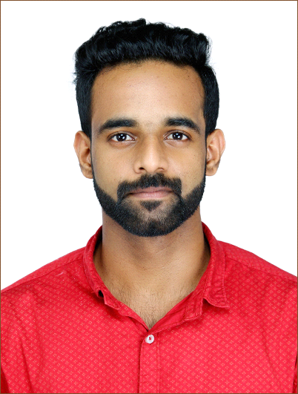
Email: afsar.339579@2freemail.com
C/o-Mobile: +971-501685421

Objective:
To attain a position where my technical knowledge can contribute to the achievement of Global Competitiveness through teamwork characterized by hard work and dedication.
ACADEMIC QUALIFICATION:
Course | Institution | Board/University | Percentage
B.E(Mechanical) | Aarupadai veedu institute of technology, Chennai. | Vinayaka mission University,  Salem. | -
HVAC | ACE INDIA | IAO | -
12 th | Bharath vidya mandir s s sch,  Valapad. | CBSE | 53.8%
10 th | Bharath vidya mandir s s sch,  Valapad. | CBSE | 70%
FIELD OF INTEREST:
- HVAC
- MANUFACTURING
- DESIGNING
- LOGISTICS
- AUTOMOBILE
TECHNICAL SKILLS:
- Software Exposure
- Modeling Software: AutoCAD, Pro-E,Basic, Ansys, Solid edge.
- Microsoft Office (Word, Excel, Power point).
- Operating Systems:Windows 7,8,10
SKILLS SUMMARY:
COMMUNICATION : Taken many seminars in college as a student.
ORGANISATIONAL ABILITY : Arranged many Industrial visits as a part of academics

OTHER INTERESTS AND HOBBIES:
- Reading books
- Playing cricket & football
- Listening to music

PERSONAL DETAILS:
Date of birth : 27-2-1992
Age : 24 years
Gender : Male
Marital Status : Single
Nationality : Indian
Languages known : English,Hindi,Tamil and malayalam
Blood Group : B ^{+v}

DECLARATION
Hereby declare that, the above said factors are true to my best knowledge and belief.I assured to share my skills, talents, knowledge, experiments and responsibility in order to provide result and plan to grow along with the company

DATE :

