Dr. REJOY
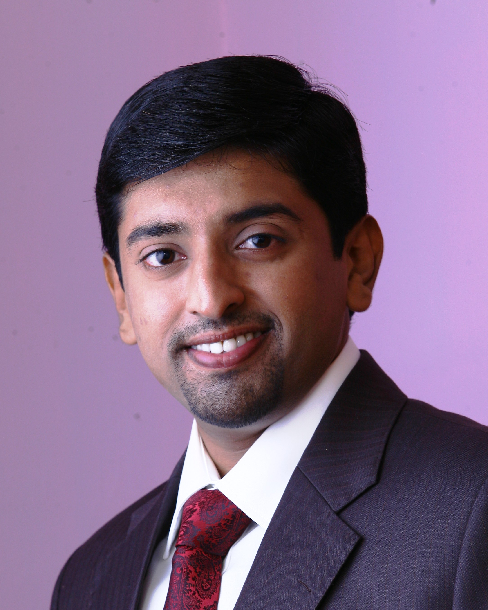

MDS–PROSTHODONTICS, FICOI

DHA ELIGIBLE (PROSTHODONTICS)

C/o- Mob- +971501685421
Email ID : rejoy.339633@2freemail.com
Career Overview :
DHA eligible (Prosthodontics Speciality), dentist with an extensive knowledge in the field of Prosthodontics for the past 3 years and 8 months. At present working as the Prosthodontistof a private firm.
PROFILE
Work experience as a BDS - Dental Surgeon
From 2008 December to 2010 May
St. George Dental Clinic

- Three years experience as a Prosthodontics post graduate student, from
2010 -2013,gained the following skills-
  - Seek patient’s dental complaints, plan and treat them accordingly.
  - Provide patients with instructions for oral care following dental treatment/surgery.
  - Knowledge of relevant drugs and patient care aids, and ability to prescribe appropriate dosages and instructions for usage.

- Possess the ability to develop and present educational programs.
- Good verbal and written communication skills.

- Clinically confident in,

- REMOVABLE and FIXED prosthodontics
- COMPLETE DENTURES – Tissue supported and Tooth supported
- Implant And Tooth Supported Overdentures
- Cast partial dentures
- Precision attachments
- Metal/all-ceramic crowns &bridges
- All ceramic laminate veneers
- Hybrid prosthesis and malo prosthesis
- Post &core restoration
- Smile designing
- Full mouth rehabilitation

Experienced in advanced surgical procedures like all on 4, indirect sinus lifts, ridge split, immediate extraction implant placement, bone expansion, bone grafts and implant placement on periodontally compromised tooth socket

Work experienceas aMDS- Specialist Dentist from MAY 2013 till Present date:
- Working as Prosthodontist&Implantologist at Alpha Dentcare Dental Clinic, Konni, Pathanamthitta.

EDUCATION
DEGREE / LEVEL | UNIVERSITY / BOARD
M.D.S | Rajah Muthiah Dental College and Hospital, Annamalai University
B.D.S | Vinayaka Missions Sankaracharya Dental college, VMU- Salem
XII Class | CBSE- Delhi, Indian School Al-ain, Abu-Dhabi, U.A.E
X Class | CBSE- Delhi, Indian School Al-ain, Abu-Dhabi, U.A.E

Professional Affiliation:Kerala Dental Council Registration Number: 7068

ACHIEVEMENTS

- FELLOW of International Congress of Oral Implantologist

RESEARCH WORKS

Two year research on shear bond strength of veneering ceramic over zirconia core and submitted it as a dissertation entitled “To evaluate the effect of an overglaze on the shear bond strength of veneering porcelain to surface treated zirconia core - An in vitro study”.

WORKSHOPS& DISSERTATIONS

- Have completed Basic Life Support (BLS) for healthcare providers course American Heart Association accredited under IIEMS Kottayam, kerala on
22-09-2016. Certificate no. e9c2732ecc7a.
- Have completed 80hrs of Theory and Hands On training on CAD- CAM under the Indian Dental Academy, Hyderbad from 24-04-2016 to 01-05-2016.
- Attended didactics & Hands on training course for Horizontal Bone Agumentation under Dr Samuel Leeat dental academy for clinical excellence Bangalore on October 18th 2015
- Have completed the Comprehensive and Advanced Implantology course (100 study hours) in Cochin dental implant institute, accredited to International Congress of Oral Implantologists – ICOI at MAY 2013
- Attended CDE Programme on “Principles of Oral Rehabilitation” conducted by Dr Shankar Iyer at R.V Dental College Bangalore in 2012
- Attended Prosthodontic Conference organized by Department of Head and Neck Surgery, Amrita Institute of Medical Sciences- Cochin in 2012
- Attended a workshop on “Comprehensive Implantology” held at Ragas Dental College & Hospital, Chennai in November 2011.
- Completed a Library Dissertation on“Implant Biomechanics”.
- Completed a Dissertation on “To evaluate the effect of an overglaze on the shear bond strength of veneering porcelain to surface treated zirconia core - An in vitro study”.

PERSONAL INFORMATION

Date of Birth | March 20, 1984
Nationality | Indian
Marital Status | Married
Languages Known | English, Malayalam,Hindi, Tamil, Arabic.

DECLARATION
All information furnished above is true to the best of my knowledge.

Dr Rejoy

