Deanne
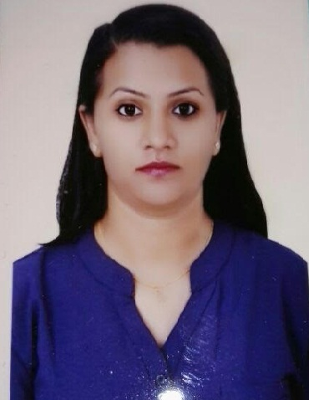

C/o-Phone: +971503718643
Email: Deanne.339664@2freemail.com

SUMMARY

I am a well presented, intelligent and highly focused individual who is keen on a career related to customer service industry. I possess over 4 years of work experience and a record of delivering great service, achieving targets, as well as recognizing and developing opportunities, doing all of this whilst contributing to the overall performance of a team. I am able to work alone or as part of a group, and understand the importance of valuable customer service and of creating a good impression with patrons. I am experienced in greeting people at a welcome desk, serving over a counter or discussing in detail a client’s needs over the telephone.

My objective is to work in a dynamic company, which will foster growth and encourage personal development.

KEY SKILLS

- Customer interaction
- Product demonstration
- Query resolution
- Customer care
- Relationship building
- Office administration
- Conflict resolution
- Attention to detail
- Communication skills
- Good IT knowledge
- Presentation skills

PROFESSIONAL EXPERIENCE
CUSTOMER SERVICE Executive January 2015–January 2017
Aramex Emirates LLC , Dubai , UAE
Aramex is a leading global provider of comprehensive logistics & transportation solutions. It is a company rapidly evolved into a global brand recognized for its customized services & innovative multi-product offering such as domestic express delivery, freight forwarding, logistics & warehousing, records & information management solutions, e-business solutions & online shopping services.

- Handling a huge network of customers within & out of UAE
- Developing and maintaining good working relationships with clients& team members
- Providing quotations on clients inquiries on shipments
- Delivering good customer service by responding swiftly to queries and concerns from clients& maintaining a continuity in business
- Maintaining detailed knowledge of new and existing products by liaising with colleagues
- Handling complaints , inquiries , quotations & coordinating with different departments when and where required
CUSTOMER SERIVICE OFFICER September 2012 –December 2014
AIA Insurance Lanka Plc, Colombo, Sri Lanka
AIA Group Limited and its subsidiaries comprise the largest independent publicly listed pan-Asian life insurance group with operations in 16 markets in Asia Pacific.

- Handling a network of customers
- Developing and maintaining good working relationships with clients
- Guiding and assisting customers during claim intimation and other general insurance related services
- Increasing profitability of existing product lines by encouraging clients to use added value services wherever possible
- Delivering good customer service by responding swiftly to queries and concerns from clients
- Maintaining detailed knowledge of new and existing products by liaising with colleagues
- Meeting promotional targets

CUSTOMER SERIVICE REPRESENTATIVE March 2012 – August 2012
Firstsource – Dialog Solutions (Pvt) Ltd, Colombo, Sri Lanka
Firstsource-Dialog Solutions is a joint venture between Firstsource Solutions, a leading global Business Process Outsourcing services provider and Sri Lanka based Dialog Telecom Axiata PLC, Sri Lanka's largest and fastest growing telecom company.

- Greet customers warmly and ascertain problem or reason for calling.
- Resolve customer complaints and coordinate escalations.
- Liaising with the assigned retail stores regarding placement of orders, refunds, or exchanges.
- System related coordination
- Inform customer of deals and promotions.
- Work with customer service manager to ensure proper customer service is being delivered.

PROFESSIONAL QUALIFICATIONS & SKILLS
- Diploma in English Language at Aquinas College of Higher Studies – Colombo, Sri Lanka
- Diploma in ICT at IDM City Campus – Sri Lanka
- Computer Skills – MS Office – Word, Excel, Powerpoint, Outlook, Internet & Web Designing,

EDUCATION
- General Certificate of Education – Advance Level Examination
  - English – (A), Economics – (C), Business Studies – (S), Logic & Scientific Method – (S)
- GCSE’s
  - English – (A), Business & Accounting – (B), Mathematics – (S), Science – (S)

Personal Details
Date of Birth : 27th August 1992
Gender : Female
Nationality : Sri Lankan
Languages : English and Sinhala
Religion : Roman Catholic
References : On Request

