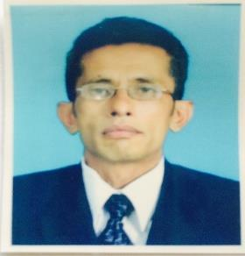

PUTHRA
Email: mehera.339668@2freemail.com

CURRICULAM VITAE

Profile

- A dedicated character with a sparkling wit and a sense of responsibility. Has a good ability to work individually as well as a team member. Always consider honesty and loyalty as the first rule of discipline. Human and sympathetic but also stern when occasion demands.

Personal Details
Name In Full | : Baba Mehera Puthra Carrim
Sex | : Male
Date Of Birth | : 05 – 10 – 1974
Nationality | : Sri Lankan Malay
Religion | : Islam
Marital Status | : Married
School Attended | :Uva College – Badulla
 | Curriculum Vitae of BMP

Work Experience

- Worked as a Quality Controller in Venture International (Pvt) Ltd. from year 1993 to year 1997.

- Worked as an Issuing Clerk in Venture International (Pvt) Ltd. from year 1997 to year 1999.

- Worked as a Quality Controller in LN Creations from 1st of January in 2000 to 19th December in year 2000.

- Worked as a Quality Controller in Comtextile (H.K.) Ltd. from year 2002 to year 2005.

- Worked as a Quality Controller in Hidramani Garments (Katunayake) Ltd. in year 2005.

- Worked as a Quality Controller in Brandix Casualwear Ltd. from year 2006 to year 2013.

- Worked as a Salesman in SWAT Trading Co. W. LL ( Electronic Items & Spare parts) from year 2014 to year 2017 January.

Curriculum Vitae of BMP

