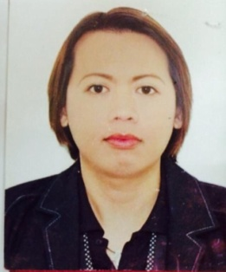
RICKY
RICKY.339722@2freemail.com

OBJECTIVE
To be part of a growing team which will help me with my career growth and where I can be an asset by providing good service and by doing the best beyond what is expected from me.

WORK EXPERIENCE

- VLCC INTERNATIONAL
Address: Sheikh Zayed Road, Dubai UAE
Position: Beauty Massage Therapist
Duration: 2009 - Present

Responsibilities Handled:
- Executing all kinds of hair treatments and facials
- Providing grooming services such as hair colour, manicure and pedicure, hand and foot spa, head massage, and scalp massage
- Doing different kinds of massage such as Swedish massage, shiatsu, thigh massage.
- Selling VLCC products.

- HAIR & NAIL CARE INT’L
Address: Mall of Asia Parañaque, Philippines
Position: Hair and Nail Technician
Duration: 2006 - 2009

Responsibilities Handled:
- Executing all kinds of hair treatments and facials.
- Executing paraffin waxing, hand and foot spa, hand and foot facial, manicure and pedicure.

- HIYASMIN SKIN CLINIC/SPA
Address: SM North Edsa Annex Quezon City, Philippines
Position: Beauty Therapist
Duration: 2004 - 2006

Responsibilities Handled:
- Executing all kinds of facial treatments

EDUCATIONAL BACKGROUND

Course: COSMETOLOGY

Year: 2003-2004

Course: CAREGIVER
Year: 2001-2003

PERSONAL INFORMATION
Citizenship: Filipino
Date of Birth: January 4, 1980
Gender: Male
Visa Status: Employment
Civil Status: Single

SKILLS AND INTERESTS
- Computer literate
- Good communication skills
- Good customer service
- Hardworking and amenable to shifting schedules
- Good in sales

