CURRICULUM VITAE
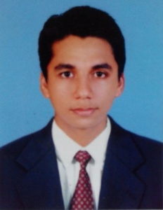
RINORAJ

Email: rinoraj.339740@2freemail.com
C/o-Mob: +971 505891826
Visa Status: Visit

CAREER OBJECTIVE

To be a part of an organization where I could use and enhance my knowledge and talent for the development of both the organization and myself.

WORK EXPERIENCE

- Position: Showroom Sales Executive (2014-2016)
Royal Enfield - Vibrant Automotive : Kannur, Kerala
Responsibilities:
- Maintain and develop good relationship with customers through personal contact or meetings or via telephone etc.
- Responding to sales inquiries from new and existing customers.
- Meeting annual sales goals and targets
- Record sales and order information and report the same to the sales department
- Provide accurate details on delivery of products to customer
- Reporting the sales report to the sales department
ACHIEVEMENTS & CO-CURRICULAR ACTIVITIES

- Achieved Best Performer Award of the Quarter/Year 2016

- Position: CNC Machine Operator
Responsibilities:
- Plans machining by studying work orders
- Plans stock inventory by checking stock to determine amount available
- Sets-up mills and lathes by installing and adjusting three- and four-jaw chucks tools, attachments, collets, bushings, cams, gears, stops, and stock pushers
- Documents actions by completing production and quality logs
- Set controls and regulated speed, feed, coolant flow and angle of cut
- Identified machine malfunctions and resolved them. Manipulated dials, switches override program and correct machine performance

ACADEMIC QUALIFICATIONS

- Higher Secondary Education – March 2007
Mambaram Higher secondary School - Kerala Board

- Plus two - 2007- 2009
Higher Secondary Education, Kerala Board

- Diploma in CNC Machine Operator 2012
Govt. Engineering College Kannur

COMPUTER AND LANGUAGE SKILLS

Operating System : Windows XP, Windows 7
Office Packages : MS Office (Word,)
Languages Known : English, Hindi, Malayalam and Kannada

PERSONAL PROFILE

Age & Date of Birth : 20-July- 1991
Gender : Male
Marital Status : Single
Nationality : Indian
Hobbies : Photography, Travelling, Driving

DECLARATION

I hereby declare that above statement and information is true and best to my knowledge.

