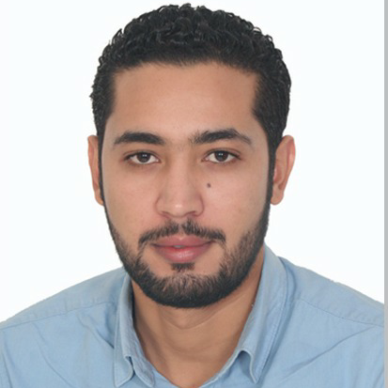

Jamal

C/o-Tel : +971505891826
E-mail : jamal.339755@2freemial.com
Address : Abu dhabi

General Objective:
To acquire a challenging position in an environment where I can best utilize my skills and education.

Professional experience

- Customer Service Executive At MUDHILA Gallery of FES ; (all Cosmetic products; perfumes, Accessory and beauty salon materials) 2014 –NOV 2016 Morocco
- Dealing directly with customers either by telephone, electronically or face to face.
- Respond promptly to customer inquiries.
- Handle and resolve customer complaints.
- Obtain and evaluate all relevant information to handle product and service Inquiries.
- Provide pricing and delivery information.
- Selling and advising customers, develop good relationship through personal Contact

- SALES EXECUTIVE: ARMEL Fes( French brand of shoes )2012 /2014
- Assisting shoppers to find the goods and products they are looking for
- Answering queries from customers.
- Dealing with customer refunds.
- Keeping the store tidy and clean, this includes hovering and mopping.
- Stocking shelves with merchandise.

- Customer Service Executive: KITEA GEANT FES Sep2010 –Feb 2012 MOR

- Selling and advising customers, develop good relationship through personal Contact
- Dealing directly with customers either by telephone, electronically
- or face to face.
- Respond promptly to customer inquiries.
- Handle and resolve customer complaints.
- Obtain and evaluate all relevant information to handle product and service Inquiries.
- Provide pricing and delivery information.

- Salesman at Marjane Hypermarkets (branch of Auchan French Company)
2008/2009
- Obtain and evaluate all relevant information to handle product and service Inquiries.
- Provide pricing and delivery information.
- Selling and advising customers, develop good relationship through personal Contact

Qualifications

- 2011-2012 :Diplomat" French school," Faculty of Arts Fes Dhar al Mehraz
- 2006:- High School Modern Letter Ibn Baja Fez
- Three Months of Training in Computer and Reparation
Maghreb-Hassoub, in Fez-MOROCCO 2008.

Computer Skills
- Office Software: Microsoft office, Photo filter, Photoshop, AutoCAD
- Language: Turbo Pascal, Visual Basic, PHP
- SDBM : Access, SQL Server
- Operating System: Windows (All versions), MS dos, Unix
- Internet : Creation and development of Websites
- Maintainer and Installation: PC Assembly and Maintainer : Park Maintainer Computer

Personal Profile
- Date of Birth : 18/03/1987
- Nationality : Moroccan
- Marital Status : Single
- Linguistic Proficiency : Arabic, English, French ,Spanish
- Visa Status : Tourist Visa

Additional complement
- Able to handle complex calls and situations.
- Demonstrating empathy and understanding when talking to customers.
- Able to deal with irate, abusive and irate callers.
- Excellent listening and problem solving skills.
- Excellent communication skills and telephone manner.
- Good keyboard skills and knowledge of customer service principles & practices.
- Strong interpersonal and problem solving abilities.
- Ability to work well under pressure in a fast paced environment.
- Ability to work cohesively as part of a team.
- Ability to focus attention on guest needs, remaining calm and courteous at all times.

REFERENCES – Available on request.

