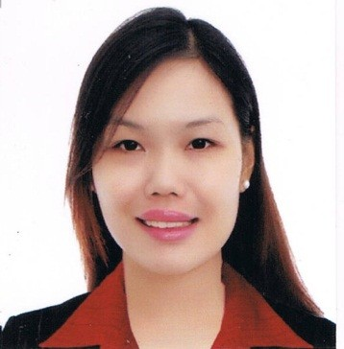
PRINCESS, CPA

PRINCESS.339763@2freemail.com

CAREER OBJECTIVE

To work with other professionals in a challenging environment to hone my skills and knowledge as a Certified Public Accountant which will allow me to further contribute in the business community.

PROFESSIONAL CERTIFICATION

May 2015 - Present Certified Public Accountant
PRC License No. 163263

PROFESSIONAL AFFILIATION

June 2015 – Present Philippine Institute of Certified Public Accountants
Member

WORK EXPERIENCE

December 2015 – Present Tax Associate
SGV & Co.
Makati City, Philippines
RESPONSIBILITIES:

- Prepares monthly returns (i.e., EWT and VAT) and the supporting computations and required attachments for the client.
- Performs income tax accrual and deferred income tax reviews in various industries (i.e., PEZA entities, merchandising/trading, real estate, services and manufacturing) in accordance with applicable tax and accounting standards.
- Analyzing the tax computations prepared by audit clients and assess whether the accounts were accorded with proper tax treatment.
- Performs tax compliance services for withholding tax on wages (WTW) and fringe benefits tax (FBT) based on the National Internal Revenue Code (NIRC), as amended and other regulations issued by the BIR and other tax authorities.
- Helps in resolving and answering clients’ queries about tax implications of certain transactions.
June 2015 – November 2015 Junior Audit Associate
BDO Alba Romeo & Co., CPAs
Makati City, Philippines
RESPONSIBILITIES:

- Conducts substantive audit procedures and prepares complete audit documentation.
- Prepares and analyzes client financials and financial ratios.
- Interviews client in relation to their financial cycle (e.g. Revenue Cycle, Disbursement Cycle)
- Assists in the identification of audit issues.
- Assists in the preparation of financial statements in accordance with International Accounting Standards/Philippine Accounting Standards.
- Prepares time budgets and audit proposals.
- Assists in preparing management letter points.

December 2012 – November 2013 Part-time Accounting Staff
Premier Physic Metrologie Co.
Mandaluyong City, Philippines
RESPONSIBILITIES:

- Writing checks for payables
- Audit the petty cash and employees’ travel advances liquidation
- Recording transactions in Quickbooks
- Summarizing the daily payables for management internal report.
- Making daily disbursement vouchers
- Verifying the cash deposited in bank.

EDUCATIONAL BACKGROUND

TERTIARY University of Perpetual Help System Dalta – Las Piñas
Bachelor of Science in Accountancy
Class of 2014

SECONDARY Las Piñas National High School
Class of 2009

PRIMARY Las Piñas Elementary School Central
Second Honorable Mention
Class of 2005

SKILLS

- Computer skills including the ability to operate computerized accounting, spreadsheet and word processing programs, and e-mail (e.g. Quickbooks, MS Office)
- Good interpersonal skills
- Can work under pressure
- Eager to enhance knowledge and skills
- Motivated and committed

PERSONAL INFORMATION

Birthday : June 15, 1993
Birthplace : Zapote, Las Piñas City
Civil Status : Single
Nationality : Filipino
Religion : Roman Catholic
Height : 5’ 3”
Weight : 124 lbs.

I hereby certify that the above information is true and correct.

