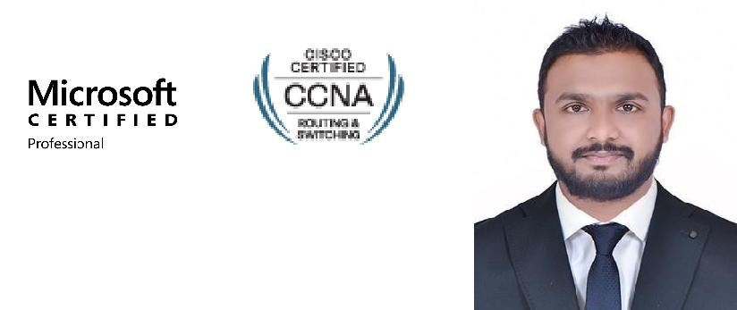
THAINDU
Email: thaindu.339764@2freemail.com

Sharjah, UAE

Career Objective

Seeking a Position as IT Support Engineer in a fast growing organization involved in an emerging technology where I could exploit my past education, professional ability & experience to develop, contribute and lead company for optimum growth and development.

Profile Summary

- Hold a Higher Diploma in computer science.
- Cisco Certified Network Associate. Microsoft Certified Professional.
- Self-motivated and great team player, Have excellent time management, co-ordination, influencing & Interpersonal skills.
- Good analytical & problem solving skills and can work under pressure to meet the deadlines. A quick learner with an inquisitive mind, committed to pursuing personal development.

Professional Experience

IT Support
Ansar Group, UAE
(Sep 2013- Till Now)

Currently working as IT Support in Ansar Group http://www.ansar-group.com/

- Creating users, groups and assigning share permissions, Group policies
- Daily and monthly backup using Symantec Backup Exec
- PABX and IP phone management using Siemens
- Managing wireless controllers and access points using Aruba Controllers and Cisco
- Configuration of switches.
- Performed basic system administration tasks on Microsoft Dynamics-Navision ERP Software
- Configure alert for triggering email for critical alerts to network switches, servers and UPSs
- Performed basic system administration tasks on Citrix Server.
- Managing and configuring POS
- Managing IT Assets Inventory
- Managing firewall and VPNs (Sonic Wall) and keep alive of VPN between site to site and Client.

Junior Technician
JKOA, Srilanka (January 2013-August 2013) http://www.jkoa.com/

- Migration of client OS
- Laptop Diagnose and repair on client side.
- Troubleshoot, analyze and fix all end users network and system related problems after the migration
- Printer/Fax/scanner configuration and support

Trainee Technician
CBA, Srilanka (October 2011 - December 2012) http://www.cba.lk/

- Undertaking the day-to-day activities like user profile creation, password reset, file sharing.
- New Installations & diagnosis of finger scanners, POS Systems, Desktops & laptop Pc’s.
- Solving Application, Software issues
- Experience of supporting a wide and varied client base.

Academic Qualification

Higher Diploma in Computer and Science (2010-2011)
INFORTECInternational Institute of Information Technologies - Sri Lanka

Professional Qualification

- Cisco Certified Network Associate - Routing & Switching
- Microsoft Certified Professional - Installing and Configuring windows server 2012

Technical Skills

- Operating System: Windows 7/8/10, Server 2008/2012 R2
- Messaging: Office365
- Virtualization: Hyper V
- Backup/Recovery: Symantec Backup Exec
- Desktop Imaging: Symantec GHOST, Acronis
- Antivirus: Symantec End point Protection, Kaspersky, Trend Micro
- Network Devices: Cisco
- IP Telephony: Siemens
- Wireless: Aruba Networks, Cisco Networks
- ERP Solution: Microsoft Windows Dynamic NAV

Personal Profile
- Date of birth | : 01-01-1991
- Gender | : Male
- Marital status | : Single
- Languages | : Sinhala, English & Hindi
- Visa Status | : Employment Visa

NON RELATED REFERIEES

Available Upon Request.

I do hereby certify that the above particulars furnished by me are true and accurate to the best of my knowledge.

