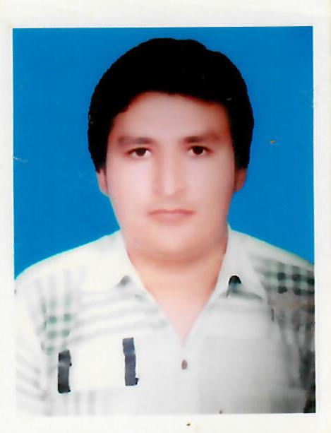
Resume
SHAHZAIB
SHAHZAIB.339793@2freemail.com

Applying for any Suitable post

Career Objective:
To render my services for a professionally managed organization that provides ample opportunities for career growth and self-development in dynamic environment that fosters thoughts and ideas.

Work Experience:
- Worked as a Salesman in Garments Company in Pakistan for the period of 1 year.
- Worked as a Senior Waiter in Al Maida Group of Hotels in Pakistan for the period of 1 year.
- Works as a Fueling Supervisor in Mobiling in Pakistan for the period of 1 year.
- Worked as a Security Supervisor in Mobiling in Pakistan for the period of 2 years.
Academic profile:
- D.A.E (civil) from P.B.T.E. Lahore, Pakistan.
- Matric from B.I.S.E Multan, Pakistan.
- Three months Diploma in Computer Information Technology Auto CAD.
- Three months Spoken English Course from I.C.C.E Bahawalpur, Pakistan.

Strengths:
- Hard Working
- Self Confidence
- Honesty
- Punctuality

Personal Details:
- Marital Status: single
- Date of Birth: 03/09/1994
- Sex: Male
- Nationality: Pakistani
- Visa Status: Visit
- Languages: English, Hindi, Punjabi.

Declaration:
I hereby declare that the above information are true and correct to the best of my knowledge and belief.

