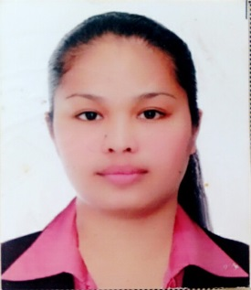
CURRICULUM VITAE

Liezel
C/o-Mobile no. +971504973598
Email: liezel.339797@2freemail.com

_________________________________________________________________________
OBJECTIVE:
To obtain a position in company that would further develop my skills and talents for continuous career improvement .I am willing to learn new skills and obtain the necessary certification that the job requires.

EMPLOYMENT RECORD

- Quantum Amusement, SM Hypermarket, Pasig City, Philippines (2011-2013)
Designation: Cashier/Clerk

DUTIES AND RESPOSIBILITIES
- Managing the cash register and accounts of the shop
- Assisting and handling the customers and in process giving them good customer service
- Assisting to up sale new promotions launched by the management
- Helping in data entry for company records

- Coach International Trade, Malabon City, Philippines (2008-2011)
Designation: Cashier/Promodiser

ASSIGNED
- SM megamall
- SM mall of Asia
- SM north Edsa
- Robinson Ermita
- Robinson Galleria

DUTIES AND RESPONSIBILIES
- Handling the cash register and accounts of the shop
- Conducting basic training to fresher’s and new employees
- Assisting and handling customers and in process giving them good customer service
- Assisting and doing outdoor sales to help promote new items and products recently launched by the company
- Petit Monde, SM City, Manila (2006-20070)
Designation: Customer Service Executive

DUTIES AND RESPOSIBILITIES
- Assisting and handling the customers and in process giving them good customer service
- Conducting basic training to fresher’s and new employees
- Responsible for doing basic data entry and handling the accounts and the cash counter if needed

- M.Y. Enterprises, Cotabato City, Philippines (2004-2006)
Designation: Customer Service Executive / Bouquet Maker/Wrapper

DUTIES AND RESPOSIBILITIES
- Responsible for preparing bouquets for parties and functions
- Responsible for flower arrangement and party decorations for events and functions
- Assisting and helping in special gift wrapping for customers
- Assisting and helping the customers to organize parties and events

EDUCATIONAL QUALIFICATIONS

- UNIVERSITY : POLYTECNIC COLLEG,
COTABATO CITY (2003-2006)
2. COURSE : BS HOTEL AND RESTAURANT MANAGEMENT (HRM)
3. SECONDARY : NOTRE DAME VILLAGE NATIONAL HIGH SCHOOL
COTABATO CITY (1999-2003)
4. ELEMENTARY : MANAN-AO ELEMENTARY SCHOOL
MANAN-AO BAROY LANAO DEL NORTE (1992-1999)

PERSONAL DATAILS

Date of Birth : March 11, 1985
Sex : Female
Nationality : Filipino
Religion : Christianity
Marital Status : Single
Visa Status : Tourist Visa

I hereby certify that all the above information is correct and true.

