CURRICULUM VITAE  ABDUL  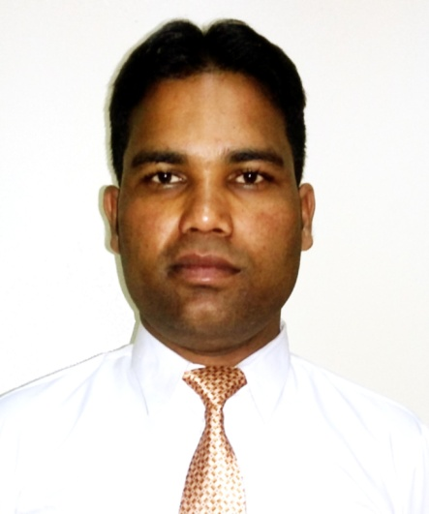  Contact Information:  ABDUL.339841@2freemail.com  PERSONAL DETAILS  Date of Birth: 10th March 1992.  Marital Status : Single  Nationality : Indian  Languages Known: English and Hindi | OBJECTIVE  A positive and self-motivated professional with good communication, sales & marketing and client facing skills, can work with minimal supervision to effectively manage the targets.  Flexible and service oriented, adaptable to change in work environment, project scopes and roles.  Good at building client relationship and building confidence in short timelines.  WORK EXPERIENCE SUMMARY  July’2011 to June'2012 at SAI PRASAD PROPERTIES LIMITED  Designation : Trainee Sales Executive  Job Role:  - Regular sale analysis in accordance to achieve target.  - Monthly Come & Forward Department (C&F) visit to complete closing session.  - Regular audit to ascertain our sales criteria.  - Understand competitors’ activities and evolving new strategies in order to increase market share.  July’2014 to JAN'2017 at COGNIZANT TECHNOLOGY SOLUTION INDIA LIMITED  Designation : Aadministrative assistant  Job Role:  - Answer and direct phone calls.  - Organize and schedule appointments.  - Plan meetings and take detailed minutes.  - Write and distribute email, correspondence memos, letters, faxes and forms.  - Assist in the preparation of regularly scheduled reports.  - Develop and maintain a filing system.  - Update and maintain office policies and procedures.  - Order office supplies and research new deals and suppliers.  - Book travel arrangements.  - Provide general support to visitors.  AREAS OF SPECIALIZATION  Major –Marketing Management Minor – Human Resource management  PROFESSIONAL QUALIFICATION  - MBA (Master of Business Administration) (2012-14) from Babu Banarasi Das Northern India Institute of Technology Lucknow Affiliated to GBTU UP.INDIA.  - BBA (Bachelor of Business Administration) (2009-2012) from DAYANAND ACADEMY OF MANAGEMENT STUDIES, Kanpur Affiliated to CSJM University Kanpur) UP.INDIA.  ACADEMIC QUALIFICATIONS  - Intermediate (B.N.R.S.P.I.C. Kashipur Allahabad) from U.P. Board in 2009.  - High School (M.G. Inter Collage Jonihan Fatehpur) from U.P. Board in 200  COMPUTER PROFICIENCY  Course: PDCAM (Professional Diploma in Computer Application and Office Management) From LYCOS COMPUTER EDUCATION CENTER, Kidwai Nagar Kanpur. Reg. with Govt. of NCT of Delhi. =16th Months.  Environment: Windows XP, Windows7, Windows8, Windows10  Web Tools: H.T.M.L.  Office Automation: MS OFFICE 2003, 2007, 2010  Other Tool: TALLY  ACHIEVEMENTS & CO-CURRICULAR ACTIVITIES  - Awarded Certificate in KANPUR WALKS FOR PARIVERTAN as a step towards SOCIAL RESPONSIBILITY at Green Park Stadium Kanpur.  - Awarded Certificate in WALKATHON at Dr. VIRENDRA SWARUP EDUCATIONAL FOUNDATION Saket Nagar Kanpur.  - Awarded Certificate in BBD Utkarsh in Cultural activity at BBD Stadium Lucknow.
HOBBIES  - Computer Surfing.  - Travelling.  - interacting people  - Team Leading.  - Increasing knowledge.  - Playing Game. | TRAINING ATTENDED  Personality Development Trainings by:-  - Randstad in year 2012 on the topic-Personality Development and Grooming.  - Reliance in year 2013 on the topic- Banking Awareness.  - Future Group and NSDC (National skill Development Corporation) in year 2014 on the topic- STAR Certification Program for Association.  SUMMER INTERNSHIP  - Internship:- @ BBA  Company : HDFC BANK  Duration : 04 Months  Department : Marketing Management (trainee)  Project Title :“THE CONSUMER BEHAVIOUR REGARDING PERSONAL LOAN.”  - Internship:- @ MBA  Company : GETIT INFOMEDIA (P) LTD.  Duration : 02 Months  Department : Marketing Management (trainee)  Project Title : “SCOPE OF DIGITAL MARKETING FOR SMEs”  RESEARCH REPORT  Research Report:-  Company : ICICI BANK (Lucknow)  Department : Marketing Management  Project Title :“THE CONSUMER BEHAVIOUR REGARDING PERSONAL LOAN’’  LANGUAGE  S.No Language Command Status  1. English Read, Write & Speak  2. Hindi Read, Write & Speak  DECLARATION  I hereby declare all the particulars given above are true to the best of my knowledge.

