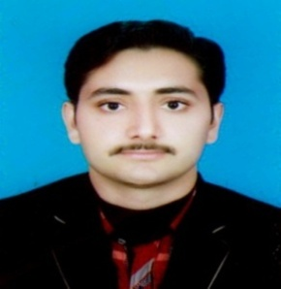
MUHAMMAD

MUHAMMAD.339878@2freemail.com

________________________________________________
Career Objective: “IT IS ONLY WHEN I AM DOING MY WORK I FEEL ALIVE.”
A career in a reputed organization providing me an opportunity to utilize and deploy my core competencies, not only to gain valuable work experience but at the same time develop managerial and technical expertise in a competitive and professional environment for a good career.
________________________________________________________________________________Education:
Sr. | Certification / Degree | Institution / University | Division/CGPA | Passing Year
1 | B.Com (IT) | Punjab University | 1st Division | 2013
2 | I.Com | Faisalabad Board | 1st Division | 2011
3 | Matriculation | Faisalabad Board | 1st Division | 2009
WORK EXPERIENCE:
Organization: Grand Tec
Organization Type: Manufacturing of Auto Parts
Designation: Accountant,Auditing,Taxation (Sale tax,Income tax,Purchase tax Maintain)
Tenure: March 2013, to Continue
Accounting Experience:
- Prepaired all type of Vouchers
- Payroll Maintain (Complete Method)
- Account Management
- Reconciling Inventories
- Visited All department of the firm (Almost)
______________________________________________________________________________________________
Computer Skills:
- Microsoft Word (Word Processing)
- Microsoft Excel ( Spread Sheet)
- Microsoft Power point ( Project Presentation)
- Internet & E-mail. Advance
- Typing,File Handling,
________________________________________________________________________________
Co-Curricular Activities/ Leisure Activities
- Event Management
- Book Reading &Traveling
- Newspaper Reading,Playing Cricket
- Command on internet surfing
_______________________________________________________________________________
Personal Detail:
Religion: Islam
Marital Status: Single
Language Competency English, Urdu, Punjabi
________________________________________________________________________________
References:
Will be furnished on demand

