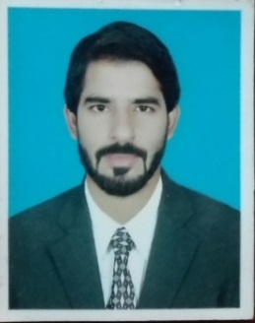**Shafique** Office Assistant

[**Shafique.339882@2freemail.com**](mailto:Shafique.339882@2freemail.com)

**C/o- +971505891826**

## Target Job

* **Target Job Title:**
* **Career Level:**Mid level
* **Target Job Location:** Pakistan
* **Career Objective:** To gain employment with a company or institution that offers me a consistently positive atmosphere to learn new technologies and implement them for the betterment of the business.
* **Employment Status:** Full time

## Education

## Graduation(2stDiv) DAE Mechanical(1stDiv)

**Punjab University PBTE**Location: Pakistan Location: Pakistan  
Completion Year:2014 Completion Year :2011

## Professional Courses

**D.I.T (1 year) DCA (06 month)**

**Sybronics Institue Cantt Acadamy of sciences**

Location: Pakistan Location: Pakistan

Completion Year: 2012 Completion Year:2007

## Experieces

Accountant at Piffers Security Services from Dec2016 to Till now.

KPO(Key punch operator) in PMI at TCS from Feb 2016 to Dec2016.

Quality control officer in Volta batteries HATTAR from Aug2014 to April 2015

Computer operator in Office of the Cantonment board wah from Dec 2013 to Feb 2014

KPO in DALDA banaspati & cooking oils from Oct 2012 to July 2013

Languages

English : Fluent (Reading/Writing/Oral)

**Urdu : Fluent (Reading/Writing/Oral)**

## Specialties

Ability to work in MS Office ,World,Excel,Power point also well known of ERP system. Window XP,7,& 8 M.S Dos, Interne Skilled in the Installation , configuration of Hardware, Software, Peripheral Devices.

Ability to communication clearly and present complex matter in learn and concise manner. Ability to listen, consult and share information and ideas.

Ability to identify, analysis and synthesis information.

***Typing Speed:***45wpm

## Personal Information

**Birth Date:** 02 Jan 1989

**Gender:** Male

**Nationality:** Pakistan

**Residence Country/City:**Pakistan/Taxila wah cantt

**Marital Status**: Single

**Number of Dependents:** 5

## References

Will be provided if required