Curriculum Vitae

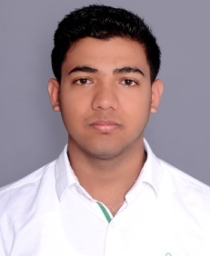
SHUBHAM
Shubham.339915@2freemail.com
C/o- +971505891826

OBJECTIVE
To work with sincerity and honesty in an organization where the knowledge can be shared and enriched. Looking for challenging and responsible jobs in an organization, where I want to develop my career in the sector with provide extra performance.
KEY SKILLS
- Communication skills
- Worked under pressure environment
- Knowledge about computer operator and cashier job
PERSONAL DETAILS
Date of birth | : 27 Jan. 1996
Nationality | : Nepali
Religion | : Hindu
Marital status | : Unmarried
Language | : Nepali, English and Hindi
Height | : 5’7” ft
Academic qualification | : SLC/+2 Management
Profession | : Computer operator/Cashier

WORK EXPERIENCE
Worked as COMPUTER OPERATOR & CASHIER AT BISHWOJYOTI SAVING AND CREDIT COOPERATIVE LTD. from 18th Oct 2013 to 27th April 2016.
PASSPORT DETAIL
PASSPORT ISSUE DATE | : 02 DEC 2014
PASSPORT EXPIRED DATE | : 01 DEC 2024
CERTIFICATION
The above furnished information is true exact as far as my knowledge. I will be appreciating for sort listing interview schedule.
Thankyou.

