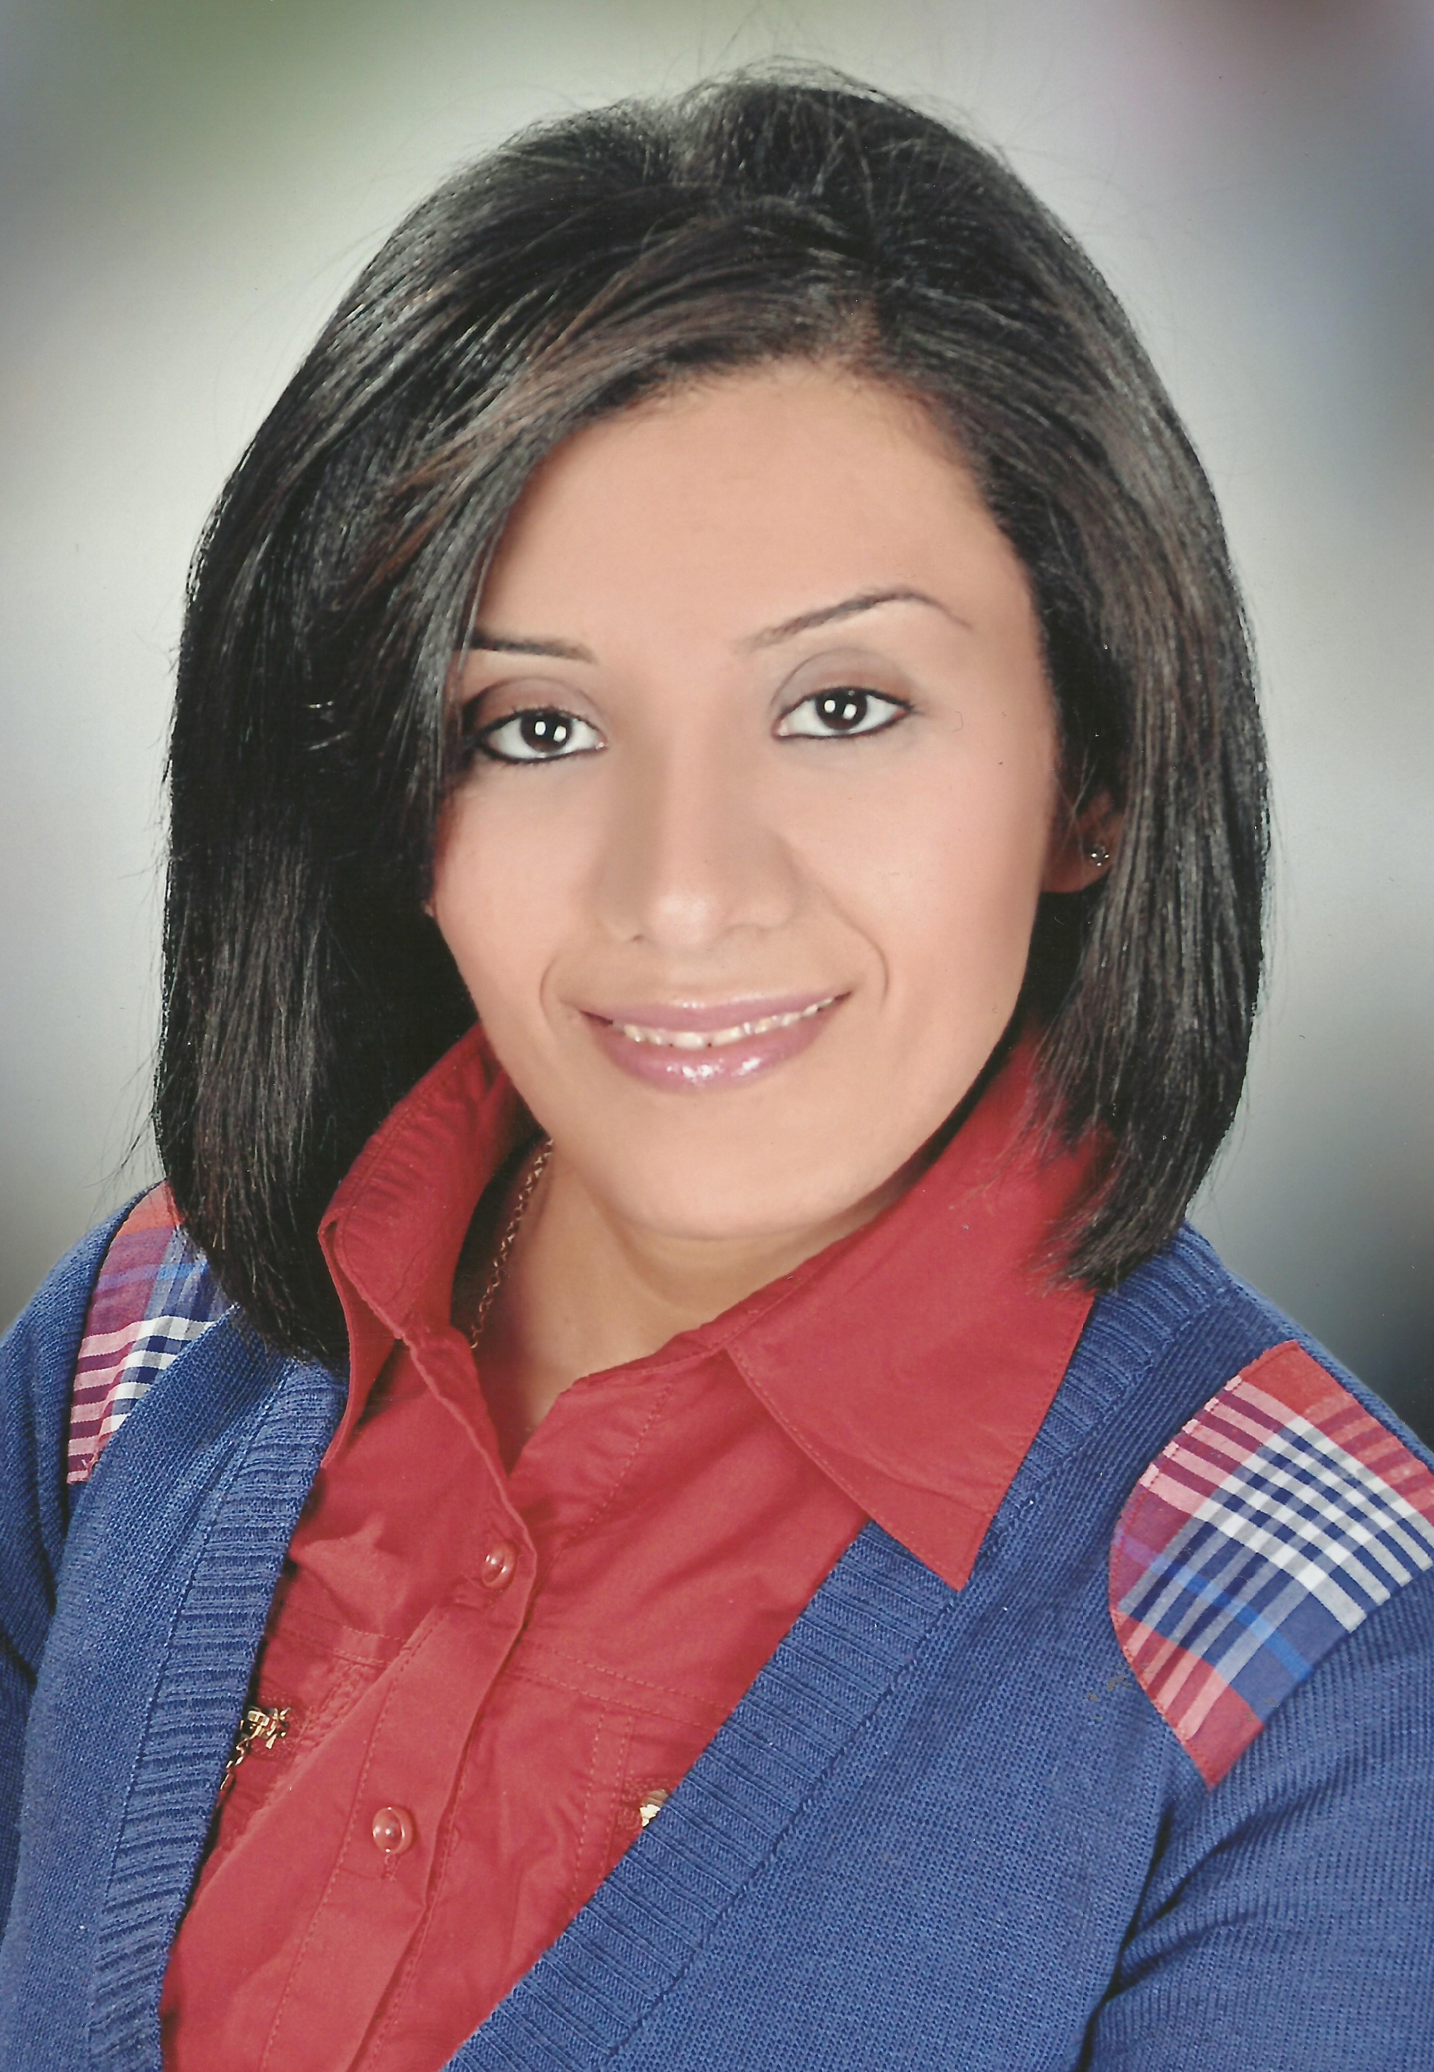
C.V
- Personal Information:

- Name : Silvana
- Silvana.339922@2freemail.com
- Date of Birth : 22nd June, 1986
- Marital status : Married
- Age : 30
- Driving license: Valid.

- Education:

- B.Sc. in veterinary medicine Assuit University, 2009 ( Degree : Fair )
- Microbiology Diploma Cairo University , 2011 (Degree : Good )

- JOB EXPERIENCE:
- 7 years in promotional field.
- Working in X.Factor ( Glope international ) since 1 / 4 / 2015 till now
- Working as medical rep in AUG pharma in zurcal line in minia since 1/ 11 / 2015 till 30 / 3 / 2015 .
- Working as Senior Medical Rep in Pharma Right Group since 1/12/2014 up to 30 / 11 / 2015
- Worked as Professional Medical Rep. For 3 Years in HKPI-JV from1/6/2011 to 30/11/2014.
- Worked as Product Specialist for 2 Years in Copad Egypt from 1/11/2009 to 30/5/2011.

- Working in : X factor
- Butter fly gel lounce
- Genoria lounch
- Refrosa
- Cruz zar
- Working in AUG pharma
- Zurcal
- G - Sac
- Working in : Pharma Right Group product
- Nexipro (Omeprazole 20mg + Sodium Bicarbonate 1680 mg) in sachet form.
- Respatio (Sildenafil 20 mg) .
- Rightiflox (Moxifloxacin 400 mg) .
- Worked on : HKPI-JV product
- Mesulid
- Ibuflex
- Cmbipress
- Globacand
- Carvipress
- Alloben
- Larithrocin
- Linezolid
- Grandoxy
- Worked on : Copad Egypt product
- Cipra pro
- Cipra max
- Memxa
- Ezo-gast .

- BRICK OF WORKING:
- Worked as act as Supervisor in EL-minia , Assuit , for 4 month in HKPI-JV
- Working as a Medical Rep in Elminia

- TRANINGS:
- In HKPI-JV:
- Basic course in selling skills
- Professional Communication skills course part 1.

- • Professional Communication skills : which consists of:
- Background
- Doctor specialties
- Match doctor/patient/product
- Promotional strategy
- Preparing discussion objectives
- Observation skills
- Questioning techniques
- Listening techniques
- Creating interest
- Promotional brochures
- Facts
- Benefits and limitations
- Providing a balanced perspective
- Resolving concerns
- Concluding discussions
- One product discussions
- Progress planner
- Discussion links
- Multiple product discussion
- Starter samples
- MAJOR ACHIEVEMENTS DURING THE CAREER PATH :
- First Best Achiever in Pharma Right in 2015 in team for 6 months .
- Achieved more than 6000 bucket in first 6 months in Pharma Right .
- Second Best Achiever in SII , line in 2011 in HKPI all product portfolio.(Mesulid , Alloben and Larithrocin ) .
- First Best Achiever in HKPI in SI and launched Compibress and Llinezolid in 2012 and SII 2013
- Launched Memxa in Copad Egypt in 2010 and Second Best Achiever in 2010
- COMPUTER SKILLS:
- Windows xp , Win 7 , Win 8.1 . win 10
- Word, Excel, Access and power point.
- MS Office package
- Internet . CRM

- LANGUAGE:

- Arabic :- mother tongue
- English :- Good

- PERSONAL SKILLS:
- Hard working and Ambitious.
- Good Communication Skills.
- Team work and group leading.
- Ability to communicate with different people.
- Self motivated, dependable & oriented.
- Ability to work alone and as cooperative team-worker.
- Good appearance and high alertness.
- Have excellent ability of convince & self confident.
- Honest, active & hard worker

