RESUME

Position applied for: | Human Resource

PERSONAL DATA |  |  | 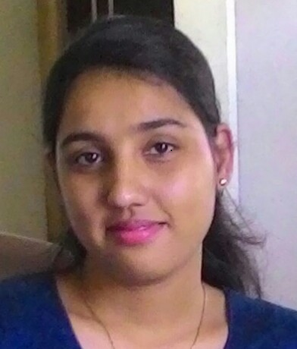
First and last name | Farha
Nationality | Indian
Gender | Female
Date of birth | 20-June-1991
Contact number/ email |  | +971504753686 |  | Farha.339937@2freemail.com
Do you have an international passport? /Visa Validity | Yes |  | On Visit Visa
International work experience? | No

LANGUAGE | WRITTEN | SPOKEN | UNDERSTANDING
English | Upper intermediate | Advanced | Advanced
Marathi | Upper intermediate | Upper intermediate | Upper intermediate
Hindi | Upper intermediate | Advanced | Advanced
Kannada | - | Intermediate | Intermediate
Konkani | - | Upper intermediate | Advanced

OBJECTIVE
A challenging role in a fast paced, open cultured organization, which offers tremendous growth potential to my career and would like to excel in the field of HR with excellent interpersonal, presentation and communication skills. I would like to utilize my ability of managing people as a key for doing well in HR stream.

 | WORK EXPERIENCE
 | Position | HR Executive
 | Company’s name | Pertinence Consultancy Services LLP
 | Duration | 2015-June 25th – 2017-Jan- 18th
 | Responsibilities | Roles and Responsibilities Carried:  Talent Acquisition:-  - Understanding the manpower requirement.  - Arranging drives and Walk Ins for Mass Recruitment.  - Identifying the candidates as per the requirement.  - Screening Resumes.  - Co-ordination between line managers & candidates.  - Scheduling interviews of candidates.  - Conducting HR round.  - Salary Negotiation and preparing the salary breakup for the selected candidates as per the salary medians across the levels.  - Maintaining all interview assessment forms pertaining to recruitment.  - Preparation of appointment letters, HR letter.  - Releasing IJP and managing the post interview process.  Operations :-  - Joining formalities (Documentation, Back Ground Verification, Induction)  - Day to Day activities inclusive (Team management, allocation of work, Day Report Generation, Client Quires and Requirements)  - Handling Employee Database (Both in Soft Form and Files Management)  - Exit-Interviews (Both In-house and External Exposure)  Employee Relation :-  - Handling all the queries of the employees. Be it related to Salary, Leaves and Attendance etc  - Also in-charged to explain the various policies, strategies and benefits to New- joiners.  - To motivate the employees on day-to-day basis.  - Team Events and Motivational Events  - Exposure for Client (Corporate) Employee engagement Projects.  Training:-  - Training Employees to work on Job portals. (Recruitment and Social Sites)  - Training on Various marketing and Social interaction skills (Both In-house and External Exposure)  - Making sure that they understand End to End Recruitment through various Task and Observations.  - Practical training for hiring and Telephone ethics.  - Basic Soft Skills and Personality Development skills. (Both In-house and External Exposure)  - Motivational Theories and Work Life balance Management Trainings (With British Connections)
SUMMER PROFESSION
Title : “HR Intern In Sumukha Engineering Bangalore”

Profile :

- To study the impact of organization culture on employees.

EDUCATIONAL/CERTIFICATION INFO
British Connections | Specialization | Year of Completion | Location
 | Train the Trainer | 2016 | Pune
RNSIT (VTU) | Human Resource (MBA) | 2013-15 | Bangalore
City College (BU) | Finance (B.Com) | 2010-2013 | Bangalore
NIIT | Tally/MS Office | 2010 | Bangalore

DECLARATION
- I declare that all information given by me in this application for employment and any sheets attached hereto are true to the best of my knowledge and I have not willfully suppressed any material fact. I accept that if any of the information given by me in this application is in any way false or incorrect, my application may be rejected, any offer of employment may be withdrawn or my employment with the Company may be terminated summarily or I may be dismissed from the Company.

FARHA

