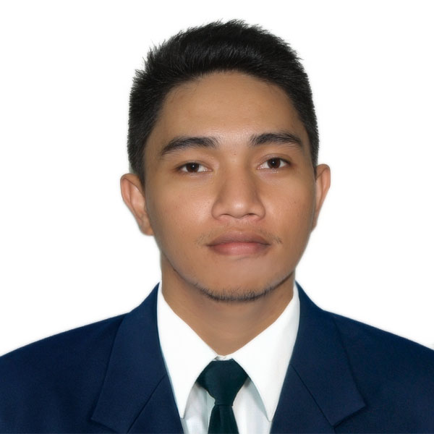
JOHN
JOHN.339963@2freemail.com

OBJECTIVE:
To share accounting and auditing knowledge obtained from experience, to have a continuous learning with the accounting profession, and to help the company in attaining continuous improvement in the field of accounting.

SUMMARY OF QUALIFICATIONS
John Paul was an Audit Associate under the Assurance practice of Sycip Gorres Velayo & Co. (a member firm of Ernst & Young Global Limited). He is a passer of the examination for Registered Cost Accountant last February 2013. He is a Certified Public Accountant since October 2014.

He has in-depth experience performing audits of mining, real estate, retailing and small and medium-sized entities.

CERTIFICATION EXPERIENCE
- Registered Cost Accountant, February 2013
- Certified Public Accountant, October 2014
- Sycip Gorres Velayo & Co.
Audit Associate, January 2015 to present
Key responsibilities and experience:
- Managed high expectations and pressure amidst the challenges in auditing significant clients of the firm. The audit engagement involves a group audit. Handled audit engagements involving mining, real estate, retailing and small medium–sized companies
- Assist in planning the audit strategy
- Prepare and monitor client assistance schedules and serve as the point of contact, log and distribute client-prepared schedules
- Conducted client interviews, managed internal meetings to facilitate the execution of the audit and performed risk assessments, data analytics and financial statement review.
- Perform walkthrough procedures
- Perform test of control procedures
- Execution of detailed audit procedures with cash, accounts receivables, inventories, investments, prepayments, property, plant and equipment, accounts payables, loans payable, equity, revenue accounts, cost of sales accounts, and administrative and operating expenses
- Observation of inventory count
- Perform audit tests in non-complex and low risk areas
- Monitor the issue log and assist in issue resolution
- Perform review of Financial Statements and disclosure checklist
- Follow through on the finalization of the audit work and audit deliverables
- Involve in different engagements involving with other Ernst and Young offices (mostly Australian Offices) wherein daily task are performed and accomplish. Primarily performing audit procedures in low risk areas, media review, and roll forward on audit procedure
- Involve in Climate Change and Sustainability Services (CCaSS) Engagement

Achievements in this role:
- Contributed to a positive team environment by demonstrating consistent commitment and optimism toward work.
- Strengthened technical knowledge in accounting and auditing; fostered teaming skills ina diversified environmentand established good professional relationship with the clients.
- Develop professional skepticism and gain a better understanding with the Philippine Financial Reporting Standards
- Department of the Interior and Local Government (DILG - CAR)
Intern, November 2011 – March 2012
Key responsibilities:
- Recording government transactions to the general and subsidiary ledger
- Verified the correctness of the amounts and accuracy of posting such to their relative books
- Update and monitor the inventory records using the weighted average as applicable accounting standard for the government

Achievements in this role:
- Obtain an experience on the accounting process in connection with the Government sector.
- Develop teaming and interpersonal skills
- Meet the expectations of my superiors with task and responsibilities assigned

EDUCATION
SAINT LOUIS UNIVERSITY
Bachelor of Science in Accountancy October 2013
Bachelor of Science in Management Accounting April 2012
Associate in Accounting Technology May 2012

RELEVANT TRAININGS (provided by SGV)
FY 2015
- Mining 101: Introduction to the Mining and Metals Industry
- Data Analysis - Hands on Training
- FY2016: Mining and Metals Industry

FY 2016
- ASSR 101 & 102: New Staff Program
- ASSR 201 & 202: Intermediate Staff Program
- Updates on BIR revenue regulations and Review of Income Tax Returns (ITR) FY16
- FY17: Mining and Metals Industry
- Mining 201: Auditing and Accounting in the Mining and Metals Industry
- ATH Introduction to Asset Management Training
- FS Review and TOC Training
FY 2017
- Valuation (w/ FSRM)
- Introduction to Asia-Pacific Talent Hub (ATH) – MANILA
- ATH and Climate Change and Sustainability Services (CCaSS) Training
- Journal Entry Testing and Global Analytics Trainings

OTHER RELEVANT SKILLS
- Can work with minimal supervision
- Proficient in Microsoft Office applications (Word, Excel and Power Point)
- Familiar and knowledgeable in business accounting software SAGE200and Tally
- Experienced in working both in small and large teams in a client-oriented environment
- Fast-learner especially when dealing with numerical data
- Knowledgeable with general accounting principles

AFFILIATION:
- Member, Philippine Institute of Certified Public Accountants (PICPA)

REFERENCE:
Available upon request.

