Curriculum Vitae
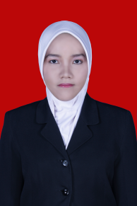
- Personal Details
Name : Annisa
C/o-Phone Number : +971502360357
Gender : Female
Email : annisa.339975@2freemail.com
Marital Status : Single
Religion : Islam
Nationality : Indonesia

- Education Details
- 1996 – 1998 SDN. Mangkura 02 Makassar
- 1998 – 2002 SDN. Candi Baru 02 Semarang
- 2002 – 2005 SMP Negeri 5 Semarang
- 2005 – 2008 SMF Nasional Surakarta
- 2008 – 2015 Chemistry Of Education Degree Sebelas Maret University

- On The Job Training
- 2010 – 2011 English Course at LIA Solo

- Awards
2010 The Winner Of PKM Kewirausahaan DIKTI

- Organization Experience
- 2008 – 2010 HMP Kimia Kovalen Sebelas Maret University
- 2008 – 2010 BEM Fakultas Pendidikan dan Keguruan Sebelas Maret University
- 2008 – 2010 UKMI Sebelas Maret University

- Job Experience
2011- 2012 Agent Insurance in Prudential
2011 PKL at SMAN 2 Karanganyar
2011 – 2014 Chemistry Teacher at Prestasi Maxima Surakarta

- Skills
IT ( windows, excel, word, power point), speaking and writing any language (English, Bahasa, Javanese)

- Personality
Good attitude, kind, comunicative, diligent, orriented, discipline, honest, and responsible.

Surakarta, 15 October 2015

