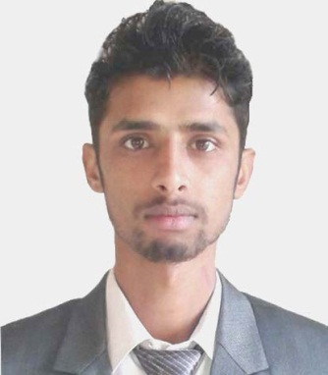
Diwash
Email :- diwash.339987@2freemail.com
CAREER OBJECTIVE
- Interested to have a challenging profession in any reputed national and international management organization.
- Like to put academic knowledge and experience into practice and to utilize my hidden talent.
- To initiate new ideas and activities in corporate or in any organization.

Employment History:

Spinneys Dubai LLC.
Customer Service Assistant (10 Jun 2016 – Running)
Org. Type: Super Market
- Assigned Duties / Responsibilities
- Handling Customer
- Goods display
- Packing

Sanskriti Infoedge P. Ltd. (My Trip 2 Nepal)
Account Executive (1st Oct 2015 – 30st May 2016)
Org. Type: Travels and Tours
- Assigned Duties / Responsibilities
-Reconciliation Sales and Purchase
- Payment Follow up
- Ageing Report
- Bank Reconciliation

Rolling Plans Pvt. Ltd.
Contract Center Representative (22nd March 2015- 23rd Sep 2015)
Org. Type: Call Center of Ncell
- Assigned Duties / Responsibilities
-Counseling the unsatisfied customers
- Handling Customer Queries

Computer Support Center
Senior Accountant (Mar 01, 2012- 30 Dec 2014)
Org. Type :Remittance and Computer work
Assigned Duties / Responsibilities
-Checking and paying the remittance.
-Counseling with unsatisfied customers
-Keeping records of transactions & cash closing.
- Analysis of Transaction
- Bank Reconciliation

-Working as a computer operator for simple Hardware and software issue.

Qualification
Degree | Majors | Institution | Board | Percentage | Year (A.D.)
Graduation (BBS) | Finance | Nepal Commerce Campus | T U | 54% | 2015
Intermediate | Business math | Vijaya Memorial H.S. School | HSEB | 59.30% | 2012
SLC | Opt. Economics and Education | Ratna Secondary School | Board of Nepal | 50.64 % | 2005

Personal Information
Nationality | : | Nepalese
Gender | : | Male
Date of Birth | : | 10 Nov,1989 A.D
Marital Status | : | Single
Religion | : | Hindu

Career and Application Information:
Preferred Job Location | : | Abu Dhabi
Preferred Industry Type | : | Banking/ Insurance/Financial Services /Sales
Preferred Job Category | : | Accountant, Cashier, Computer Operator etc.
Preferred Position | : | Entry Level
Years Of Experience | : | 4 years

Languages | Writing | Reading | Speaking
Nepali | Excellent | Excellent | Excellent
English | Very Good | Excellent | Very Good
Hindi | poor | Good | Very Good

Trainings:-
- Computer Application
- Graphic Design
- Accounting Package
- Hardware and Software

