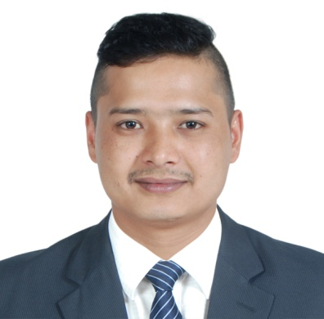
PRAKASH

Dubai
Email:prakash.340011@2freemail.com
C/o- +971503718643

PROFESSIONAL PROFILE

Seeking a challenging position with a progressive organization that will effectively utilize my knowledge and expertise, where I can grow with the organization and prove to be an asset for its effective functioning, be a team player for the achievement of organizational goals and its success.
QUALIFICATIONS

- Motivated and hardworking
- Flexibility in working conditions
- Individual, skilled in problem-solving
- Responsible, efficient with an excellent work ethics.
- Excellent interpersonal and communication skills.
- Proven ability to work under pressured environment with less supervision.

EDUCATIONAL ATTAINMENT

- COLLEGE/UNIVERSITY : GATE (GLOBAL ACADEMY OF TOURISM HOSPITALITY EDU.)
- COURSE/DEGREE : HIGHER DIPLOMA IN HOTEL & RESTAURANT MANAGEMENT
- YEAR : SEPT 2012

COMPUTER SKILLS

- MS Office (Word, Excel, PowerPoint)
- Email & the Internet Explorer

WORKING EXPERIENCE

COMPANY : M.H ALSHAYA (Texas Roadhouse Restaurant) Dubai
POSITION : Team Leader – CASUAL DINING
YEAR : MARCH 2014 – UP TO PRESENT

DUTIES AND RESPONSIBILITIES

- Diplomatically handle customer complaints regarding service and food and beverages, take corrective action.
- Train the traine.
- Provide the maximum knowledge and skill to the trainee about food and beverage, and according to the standard of the brand.
- Prepares daily opening and closing reports of the dining restaurant
- Take orders communicate with kitchen and deliver foods promptly
- Entertain the guest, Escort guest to their table.
- Present menu to patrons and answer question about the menu items.
- Responsible for entertaining and assisting the customers upon entering the restaurant.
- Present menus to patrons and answer questions about menu items, making recommendations upon request.

COMPANY : CELEBRATION EVENTS HEIGHT, (Nepal)
POSITION : EVENT COORDINATOR/BAR SUPERVISOR
YEAR : AUGUST 2011 – JULY 2012

DUTIES AND RESPONSIBILITIES

- Managing kitchen staff
- Handling deliveries
- Enforcing health and safety rules
- Recruiting, training and motivating staff
- Doing regular stock-takes and ordering as necessary
- Maintaining the condition of beer and wine
- Overseeing or liaising with the kitchen
- Dealing with difficult customers
- Keeping up to date with licensing legislation and taking legal responsibility for the premises
- Ensuring beer and wine are kept in good condition
- Deals with the customer queries and product information about the brands.

TRAINING/EXPERIENCE

- Restaurant Management Training at Bangkok, Thailand (Sep 2013 – Dec 2013)
Responsible for all the outlets of restaurant
Responsible for learning Budgeting, set target, cost control
Responsible for opening and closing of restaurant
Responsible for check equipment and inventory

- Celebration Events Height (Nepal) (Feb 2011 – July 2011)

- Hyatt regency Kuantan, Pahang, Malaysia (May 2010 – Dec 2010)
Worked at the fine dining restaurant, casual dining restaurant, and bar.
Successfully meet the customers ‘expectations with the highest level of service standards.

PERSONAL INFORMATION

DATE OF BIRTH : 22 – 01 - 1991
NATIONALITY : NEPALI
RELIGION : HINDU
MARITAL STATUS : SINGLE
LANGUAGES : ENGLISH, HINDI & NEPALI
VISA STATUS : EMPLOYMENT VISA

I hereby certify that the above information mention is true and correct to the best of my knowledge and belief.

