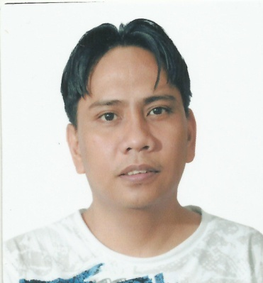
Philip

C/o-Mobile No.:+971502360357
Email Add: Philip.340016@2freemail.com

CAREER OBJECTIVE:
To obtain a position in competitive establishment where my technical knowledge and experience can be initialized while contributing to its growth.
To be able to work in the company where i can possibly utilize my acquired skills and knowledge in support of department goals and objectives. A responsible job in this company that will gain more knowledge and to be a part of the growing company to enhance my skill of the chosen field.

WORK EXPERIENCE:
- Position: Computer technician (Hardware/Software)
Duration: March 28, 2013 – Dec.3, 2016
Company: Compack Disk For Computer ( LAPTOP WORLD )
Location: Jizan City Branch Kingdom of Saudi Arabia,Along Airport Road
Job Description: Responsible for repairing all brands of laptop like ACER,DELL,SONY etc.(hardware problem) especially for repairing motherboard of laptop such as No power,No display etc., Formatting windows 7,8 &xp and testing all units incoming and outgoing laptop, Repairing charger laptop,LCD monitor,printer etc.

- Position: Computer technician (Hardware/Software)
Duration: June 19, 2010 – Aug. 13, 2012
Company: AL-NEBRAS COMPUTER
Location: Sanabes, Dammam Kingdom of Saudi Arabia
Job Description: Responsible for repairing computer desktop and laptop especially for repairing motherboard of laptop and desktop, knowledgeable of repairing electronics such as LCD monitor, laptop charger,power supply of desktop,change laptop LCD/LED, hardisk,memory/RAM, etc. (knows how to repair all brands of laptop,any kinds of problems/trouble)

- Position: Auto Electronic Technician/ Car Electrician
Duration: March 9, 2008 to March 20, 2010
Company: ALGARAWI CAR MAINTENANCE GROUP
(Specialized in Ford & GM Cars)
Location: P.O. Box 333 OnainzahGassim 81888
Kingdom of Saudi Arabia
Job Description: Repairing/troubleshooting electrical and electronics such as computer box, etc.

- Position: Production Technician
Duration: March 12, 2007 to August 7, 2007
Company: GOLDMANN Industrial Corporation
CAMEL SERVICE CENTER
Location: National Road, Malhacan, Meycauayan, Bulacan
Job Description: knowledgeable in repairing/troubleshooting electronic appliances especially audio/video products such as television,VCD/DVD player, stereo component, electric fan, etc.

- Position: Audio Video Technician
Duration: April 6, 2006 to October 6, 2006
Company: AIREFLEC Appliance Services
Location: Panasonic Authorized Service Center
Brgy. Tagapo, Sta. Rosa, Laguna
Job Description: Responsible for repair different type of electronics appliances such as colored television, stereo component, DVD, VCD player, stereo karaoke, etc.; knowledgeable in repairing the following brand (Panasonic, SONY, Sharp, JVC, SANYO, SAMSUNG, etc.)

- Position: Electronic Technician
Duration: June 15, 1998 to December 2004
Company: SOLID ACE SERVICE CENTER
Location: Panasonic Authorized Service Centre
123 Banal St., 6th Ave., Caloocan City
Job Description: knowledgeable in repairing/troubleshooting electronic appliances especially audio/video products such as television, VCD/DVD player, stereo component; responsible for repair customer’s unit brought by customer in our shop of warranty or under warranty unit; Responsible for repair different type of electronics appliance unit such as rice cooker, electric stove, microwave oven, flat iron, electric fan, etc.

SEMINARS ATTENDED:
- CTV Panasonic Model Sophia Series and Evolution or PX1 chassis.
- CTV Panasonic Model 2001 Flat Screen TC – 21F3, PX2 chassis
- Model SA – AK122 – Alignment of CR16 CD mechanism.
- Mini-Component 2004 Model – Alignment of CR20 CD mechanism.
- CTV Panasonic 2004 Model TC – 21FJ30P or PX5 chassis.

PERSONAL DATA:
Age : 39
Birthdate : January 27, 1977
Birthplace : Manila
Religion : Roman Catholic
Civil Status : Married
Nationality : Filipino
Height : 5’0”
Weight : 140 lbs.

EDUCATIONAL BACKGROUND:
Vocational : 1994 – 1995
Electronics Technician/Television Mechanic
GUZMAN INSTITUTE OF TECHNOLOGY
Secondary : 1991 – 1994
Colegio de Sta. Cecilia
Primary : 1986 – 1991
General Tibucio De Leon Elementary School

