MADAN
Email: madan.340027@2freemai.com

POSITION DESIRED

Accountant

CAREER OBJECTIVE

A self motivated person looking for a stable company where I can apply my analytical skills and commitment to perform quality work.

WORK EXPERIENCE

Senior Inventory Staff
March 2015-present

Dubai, United Arab Emirates

Founded In 1992, Majid Al Futtaim is the leading shopping mall, retail and leisure pioneer across the Middle East and North Africa ( MENA). It has since grown into one of the United Arab Emirates Most respected and successful businesses spanning 12 international markets, employing over 26,000 people. It holds exclusive rights to the Carrefour Franchise in 19 markets across Mena and Central Asia, operating a portfolio of over 50 hypermarkets and over 55 supermarkets in 12 countries.

- Monitors and maintains current inventory levels; processes purchasing orders as required; tracks orders and investigates problems.

- Records purchases, maintains database, performs physical count of inventory, and reconciles actual stock count to computer-generated reports.

- Receives, unpacks, and delivers goods; re-stocks items as necessary; labels shelves.

- Processes and/or approves invoices for payment.

- Processes and documents returns as required following established procedures

- May serve as cashier and handle cash and cash-related payments.

- May lead, guide, and train staff/student employees, interns, and/or volunteers performing related work; may participate in the recruitment of volunteers, as appropriate to the area of operation.

- Performs miscellaneous job-related duties as assigned.

SUMMARY

Expertise in inventory control for 2 years, Ordering and receiving of goods/ items, Training of newly hired inventory staff, Account receivables/ payables, Cash flows and expense management, bank/ accounts Reconciliation, knowledge of supplies, equipment, and/or services ordering and inventory control

ACHIEVEMENTS

ACCA (UK)- Diploma in Accounting

and Business

Diploma in Commerce and Management

STRENGTH

- Pursuing the ACCA advanced papers

- Ability to work under pressure

- Well- motivated to learn more in planning and development

- Accurate, efficient and keen on details

- Excellent knowledge of Account receivable / payable

PASSION
Finance

WORK EXPERIENCE MY TIME

Accountant
Gorkha Department Store
Damak Nepal (2014-2015)
- Coordinates with the bank regarding inward received and payments made

- Prepare journal entries, payments and receipt vouchers

- Handling and maintaining cash floats

- Resolve accounting discrepancies and irregularities.

- Prepare bank reconciliation statement on monthly basis

- Ensure all financial reports are submitted on time

- Performs routine clerical duties, including data entry, answering telephones, and assisting customers.
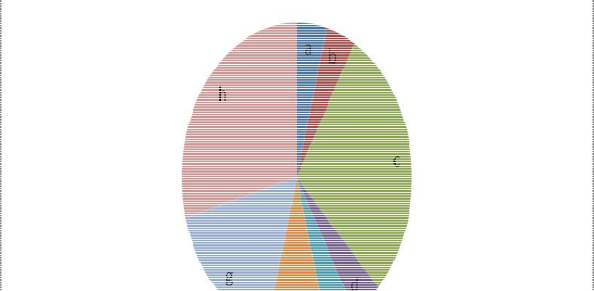

EDUCATION

ACCA- Diploma In Accounting and Business

March 2016 Dubai, UAE

Diploma in Commerce and Management

2011-2013 Jhapa, Nepal

LANGUAGES

English – expert
Nepali – Native
Hindi – expert
Urdu– expert

QUOTES

The capacity to learn is a gift, the ability to learn is a skill, the willingness to learn is a choice.

-Brian Herbert

- Praying

- Taking updates from sales manager and building a business development strategy

- Performing jobs related to inventory control, training of newly hired inventory staff, working along with them and showing the essence of teamwork in the workplace

- News Channel

- Taking care of environment by being an active member of various environmental care-taker groups in social media and in Nepal

- Sports and entertainment/ Social life

- Studying ACCA F4 Corporate Law and F5 Performance Management

- Sleeping and dreaming about work in Finance

