LINTU

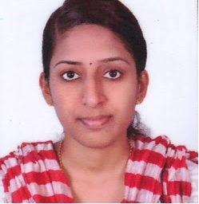

C/o- +971501685421

Email: lintu.340062@2freemail.com

CAREER OBJECTIVE

A job position that allows the maximum utilization of my educational qualification
and professional skills for improving the health status of patients and assist the doctor in the
effective implementation of treatment.
.

MY STRENGTH

I am empathetic and self-motivated, I can communicate reasonably well.
I have a good level of emotional intelligence to get along with different type of patients
and colleagues and I can keep myself cool in hard times. I am trained to be proactive.

CLINICAL EXPERIENCE

NAME OF HOSPITAL | PERIOD OF EXPERIENCE | YEAR OF EXPERIENCE | DEPARTMENT
Indira Gandhi Co-Operative Hospital,Thalasseri | 01-03-2014 to 1-5-2016 | 2 Years& 2 Months | Medical Surgical
VIMS Hospital,Kallachi-Kozhikode | 01-06-2016 till date | 7 months | Medical Surgical

ACADEMIC QUALIFICATION

  - HAAD RN Passed (10/01/2017) -- AGN 177964

  - BSc NURSING(2009-2013)- 68% ,Kannur University,
Canossa College Of Nursing, Cherukunnu-Kannur

  - Plus Two(2007-2009) – 83 % NSS HSS , Alakode

  - SSLC – (2006-2007)Board of Public Examination, Kerala

PERSONAL INFORMATION
Nationality : Indian
Gender : Female
Religion : Christian
Date of Birth : 28th August1991
Marital status : Single
Languages : English, Hindi, Malayalam, Tamil
Hobbies : Listening Music, Reading

DECLARATION

I hereby declare that the above stated information is true and correct. Given an opportunity in your esteemed organization I will discharge my duties to best of my abilities and your utmost satisfaction.

