Ashutosh
Email: ashutosh.340067@2freemail.com
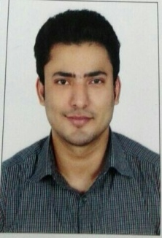

Education
Maharashtra Board Uttarpradesh Board University of Mumbai
Std: XthStd: XIIth, Science Stream B.M.M- Bachelor of Mass Media
Academic year: 2007-08 Academic year: 2010-11 Academic Year: 2013-14
Passed class: second Passed class: Firstpassed class: Second

Experience
Marketing Executive at Freight Carriers, domestic transport company in India.
Working Duration: Oct 2014 to Jan 2017.
Work: handled all type of marketing Media, handled all office work, building good relation to clients, handling all advertising media.

Objective
- Working in target environment with quality as backbone of work.
- Learning new marketing strategy, and implementation of problem solving techniques.
- Working in a team keeping a team spirit high.
- To work with innovative ideas.

Interests & Activities

- Sports
- Music
- Dance

Computer Skills
- Proficient in Microsoft Word
- Proficient in Internet
- Basic in Microsoft Excel

Career mission objective
Seeking a position in Marketing wherein I can utilize my communication skills and my Bachelor of Mass Media degree to build a strong Business network for achieving a higher market penetration level.

Nationality: Indian
Gender: Male
Marital Status: Unmarried
Language known: English, Hindi.

Declaration

The information given above is true to the best of my knowledge and will be responsible
For any flaws in it.

